**Python notes**

**Legacy**- a software has been installed on most devices .

e.g. Python 2.x is a legacy software version/build.

**Virtual environment­**- a tool to keep projects. E.g Vscode python environments, virtualenv , etc. A virtual environment separates all dependencies required by different projects in separate places. This is done so each programme can run safely without interfering with another.

**IDE-**Intergrated Development Environment

**Syntax in Python-** A set of rules that determine how a python programme will be written and interpreted.

**In Python programming we work with syntax and commands to create code to perform different tasks ( input ,compute, display an output etc.)**

**+**

**VARIABLES**

**Variables**- a datatype capable of containing changeable values .

2.A name that contains changeable values.

In order to understand variable, we have to understand **values**  in programming.

**Similar to finding *x*  in mathematics. A variable is the “x” in Python.**

**Values-** categorized according the type of data they can handle.

Examples; “Hello Ontisitse”, “2”, “2.1”

**“Hello, Ontisitse”- statement**

**“2”- integer**

**“2.1”- float point (decimal points)**

**True- Boolean data type**

“Hello, Ontisitse” is classified as a string because it contains a string of letters.

“2” is classified as an integer because it contains a whole number

“2.1” is a float point because it contains a decimal.

The value of a variable is assigned using **assignment statements.**

**X=13**

**Message=”I am a Python programmer”**

**Y=365.2565**

We assign a value to a variable with the **‘=’** sign.

The equal sign is called the **Assignment operator.**

**The left hand, right hand divide is a rule and cannot be written opposite. Meaning the value cannot be written on the left hand side. Likewise, the variable cannot be written on the right hand side.**

e.g “I am a Python programmer”=message X

**Variable rules**

**Variables must:**

1)Always begin with a letter

2)Never use illegal characters(@,$,&,%, etc.)

3)Never use a python Keyword.(class,type,syntax,etc, print,from,from,pass,else,lambda, del,finally,and,exec,continue,if,while,assrt,except, etc.)

**If interpreter complains about syntax error, check the variable naming.**

**STATEMENTS**

**Statements** are instructions.

**EXPRESSIONS**

**Expressions-** Is a complete though, with a premise and a conclusion.It has an iput,a defined use of that input.It is also expected to display that output directly or compute the output.

**An expression generally contains a combination of variables, values, statements and assignments operators that force the interpreter to display results.**

**A value and variable are simple expressions in Python.**

**Print(“Hello”, + str(12567), + “This is your new home”)**

**OPERATORS AND OPERANDS**

**Operators-** special symbols

**Operands-** The value that the operator uses.

Rounding off to the nearest, **//**  is used

Regular division

**OPERATIONS AND STRINGS**

The ‘**+**’ , addition sign can be used with strings. However, unlike in mathematics where this sign is used for addition, in strings, it is used as a concatenation( interlinked expression, joined, conjugate, conjoined, continuation, succession, etc.)

Multiplication also works on string(*).

**FUNCTIONS**

**Function-** a block of code which only runs when **called**

**Calling** a function means using the function name and not copying the entire code again, and giving the function an input it can compute.

Function_Name(parameters)

**Parameters-**values/inputs assigned to the function.

**Function_Name-** function you want to use.

**CONDITIONAL Statements**

Conditional statements

If-statement

If-else statements

These statements have Boolean results meaning the results are either true or false.

**Here is a code for a computer. This computer is used by a courior company which charges a flat rate for items weighing less that 60Kgs. If items weigh more than that, a R400 extra charge is applied.**

**weight=(Input(“Please enter your parcel:))**

**Def input():**

**If weight>60:**

**print( weight +is above 60kgs )**

**print(“Thank you”)**

**attached is if-else statement**

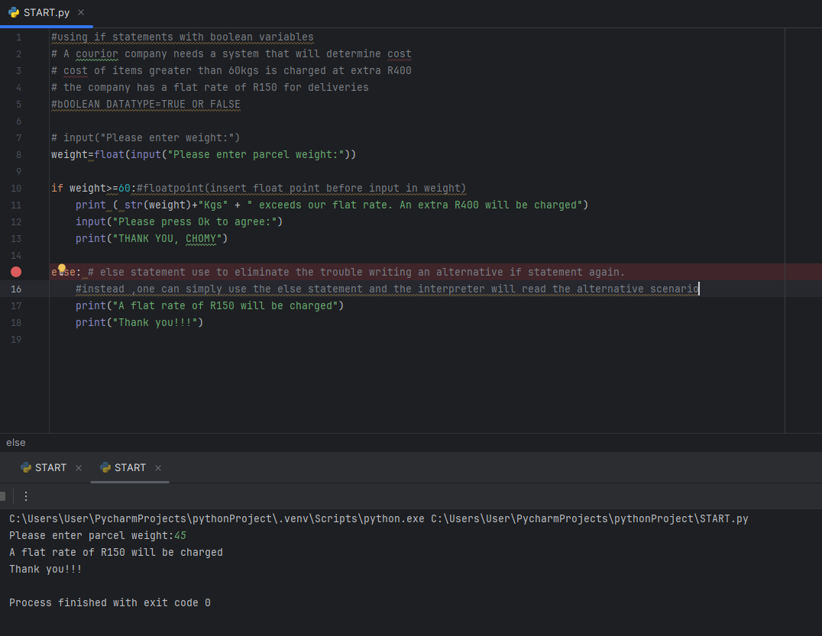

**Followed by if-elif**

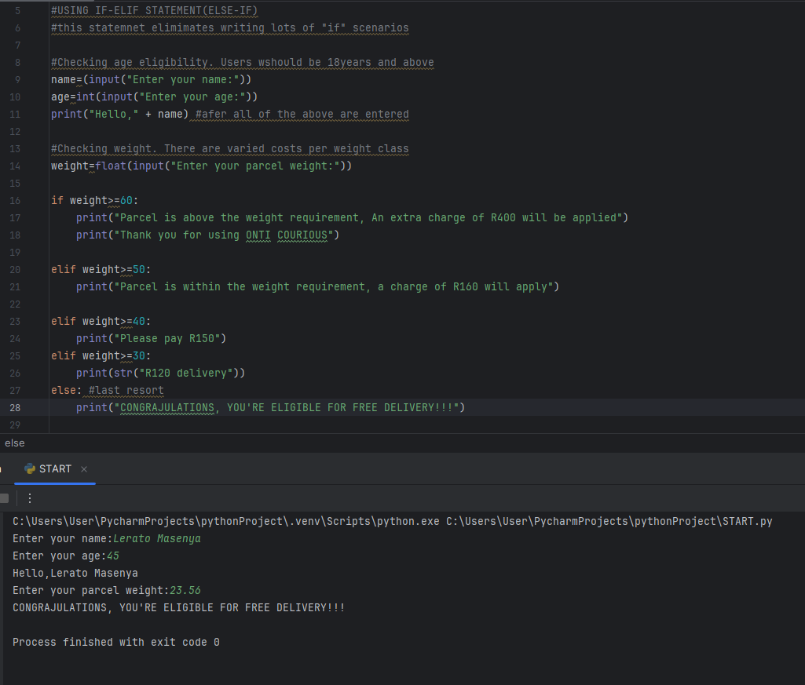

**Functions-related statements that perform a certain task, they help us break a programme into smaller and more manageable pieces.\**

**Syntax for own function**:

**Ddef function_name():**

**Ddef means definition of a function**

**Function-name is simply the name of your function. You can use any name.**

**Parentheses is where values or parameters will be attached**

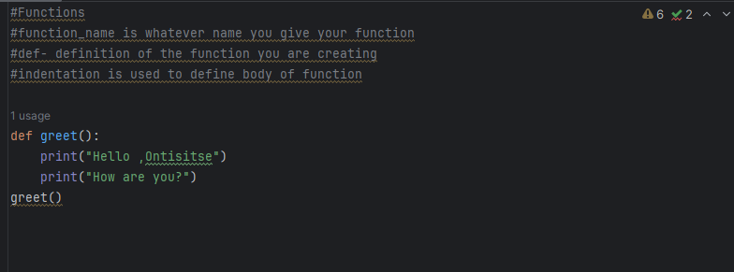

**We can add arguments to functions**

greet() -  **we call(instruct the function to display the code in its body) by using parentheses without colon.**

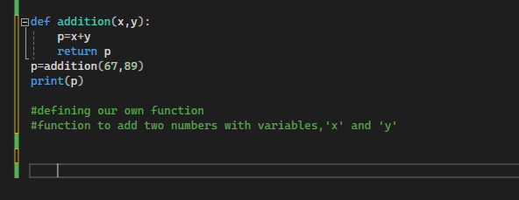

**We can add arguments to the previous function**

def greet (**name** ): ‘**name’ is new variable(parameter)**

print(“hello” , name)

print(“How are you?”)

greet**(“Ontisitse”**) “**Ontisitse” is the new argument**

**Name** accepts whatever argument is present

When we run this programme, it will print **“Hello, Ontisitse”**

**How are you?**

**Passing multiple arguments**

We can use the function to add numbers, multiply numbers and so on.

def function_adds_two_numbers(x,y): -**x,y**  are new variables

p= x + y

print(“ the sum of the two numbers is”, p )

n1=15

n2=16

function_adds_two_numbers(n1,n1) – **call function**

**INDENTATION INDENTATION INDENTATION INDENTATION**

**Loop Statements**

There are two type of Loop statements:

**For-loop**

**While- loop**

**Loop control statements** are used to determine when a loop starts, continues and terminates.

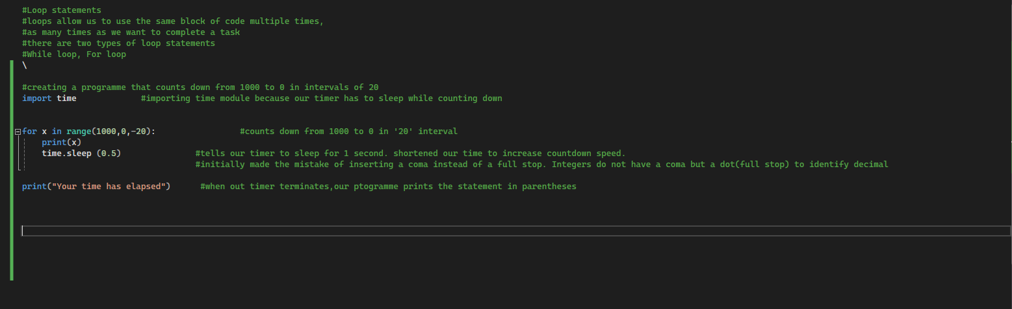**For loop-** statements are the multiple use of a block of code to complete a task.They can be used for as long as there are parameters in a list.

**Syntax ya “For-loop” statement**

**Ffor variable/ function in sequence/list:**

**Indented statement of choice**

**List type for ‘For-loop’**

**[1,2,3,4,5,6,7,8]**

**[“Ontisitse”,”Tiisetso”, “Mpumelelo”]**

**[ “Sunday”, “Monday”, “Saturday”]**

**[1,”words”,”bicycle”, 45,-98]**

**[]- these squared brackets indicate an empy list**

**Ffor name in[“Ontisitse”, “Deco”,”Tiisi”]**

**Print(name) - will print names in a sequence**

**Print(“Hello”, name) -will print;**

**Hello Onti**

**Hello Deco**

**Hello Tiisi**

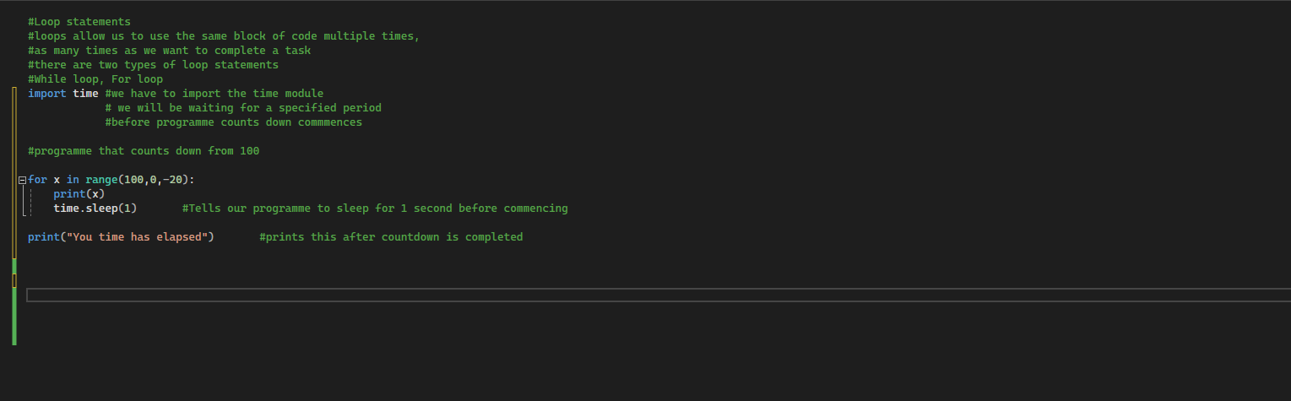**Loop using the Range function**

**Syntax for function**

**This is basically a for-loop with a ‘range’ function**

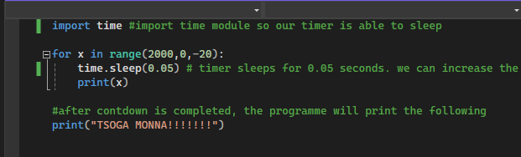

**Ffor x in range(insert variable):**

**Print desired string -srting will be printed as many times as variable entered**

**Ffor x in range(9)**

**print(“Molebogeng”)**

**Molebogeng**  will be printed 9 times

We can create a programme that asks user how times he’d like his input to be repeated

Here is the code

K=int(input(“How many times would you like me to repeat your input?”))

For x in range (K):

Print(“Onti” -Onti will be printed as mnay times as whatever value was inserted in K

**While loop**

**While loop-** A Boolean loop that repeats the same set of commands until the original scenario is False.

**Syntax for While-loop**

**Wwhile** expression:

Pprint desired statement(s)

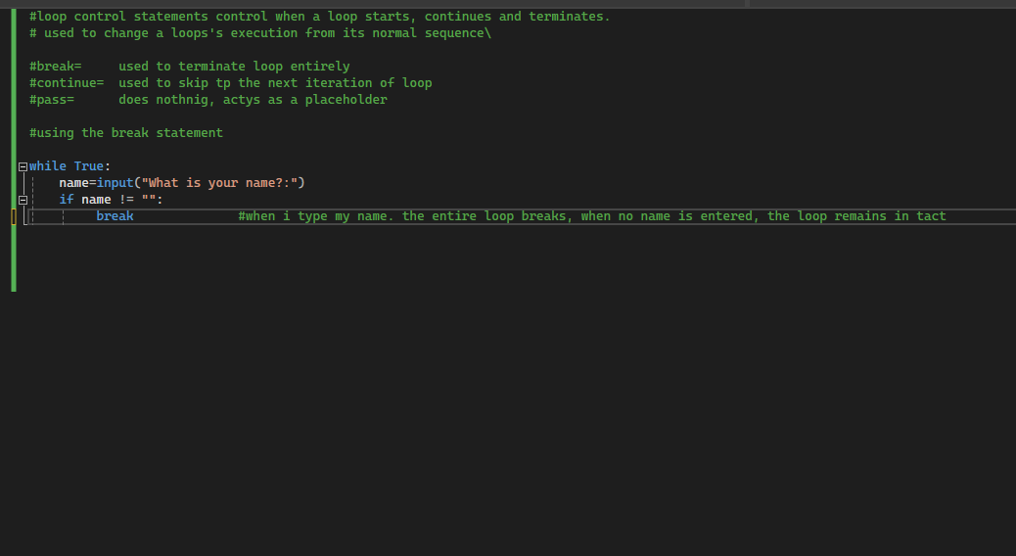

**Infinite Loop**

**The infinite loop means the condition of programme NEVER becomes False. It runs non stop and keep asking the user for input.**

**Example:**

**Syntax for infinite loop**

**N=1**

**While n==1:**

**A=Input(“Please enter value:”)**

**Print(A)**

**Loop control statements**

**Three types but I will use two:**

**1) Continue - this skips the next iteration in the loop.**

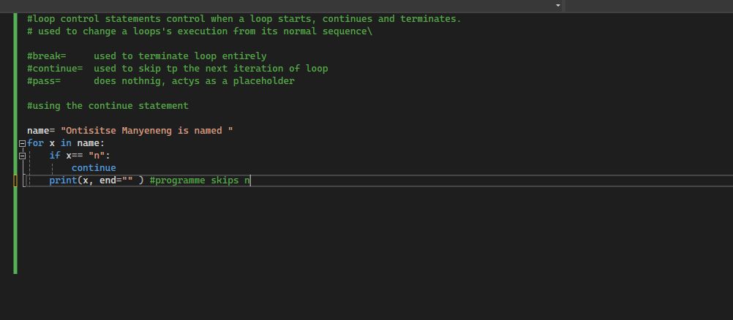

**Another example:**



**2)Break - Used to break or terminate a while loop when original loop**

**When original loop conditions are no longer being met.**



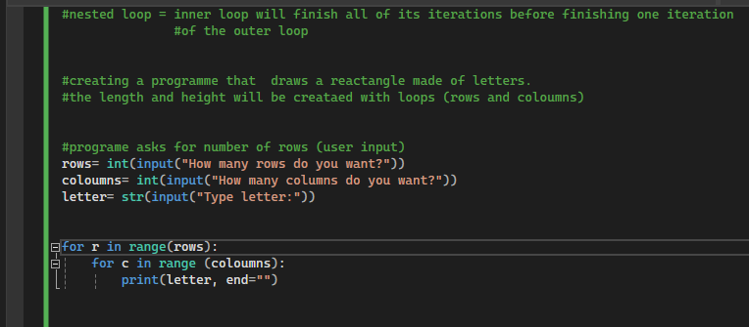**Nested loop**

**Lists**

**Lists** store values, names and contacts , numbers ,etc. The values in a list are counted from zero to one. Lists allow values to be added and removed at will.

**Tuples** similar to lists but their values cannot be modified. Once they values are created , they remain static for the rest of the programme. Also start from zero.

**Dictionaries** allow you to create an index of words where each word has a unique definition. The **definitions(values)** and **words(keys).** The words, like those in a dictionary are not numbered. The values in a dictionary can be added, removed and modified.

Working with  **Lists**

Syntax of list:

Ffor x in (name of list):

Print(x)

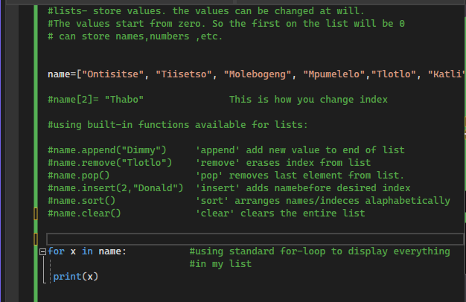

**2D lists**

**2D lists-** these are lists of other lists. We can create one list housing 4 lists.

Syntax for 2 lists:

For x in (name of list):

Print(x)

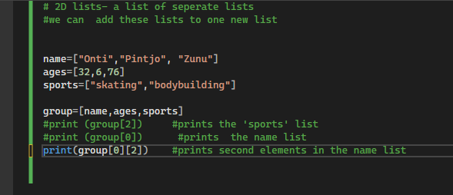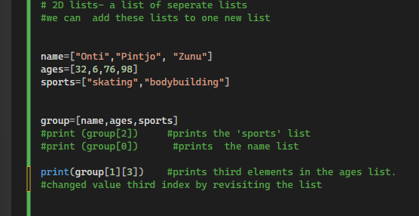

**Tuples**

**Tuples** are similar to lists but have values that cannot be be changed. They are also numbered from zero(0) index.

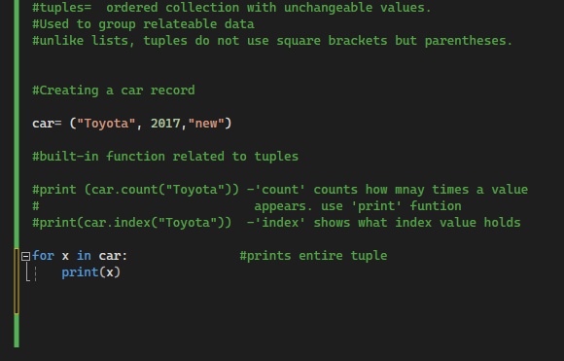

**Checking if value exists in a tuple. Use if statements**

Syntax:

If (value) in (name of list):

Print desired statement

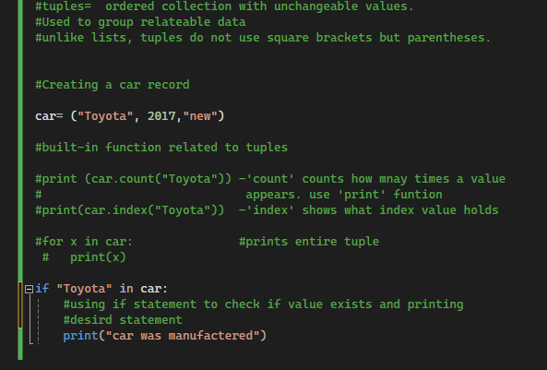

**Set**

**Set** is a collection of values that is unordered, unindexed. Has no duplicate values. Is not counted from zero.

Syntax for set :

Name of set={“value”, “value”}

For x in (name of set):

Print(x)

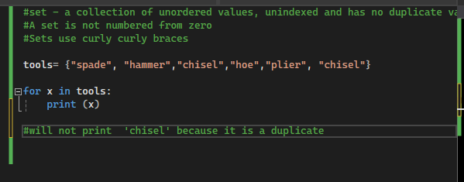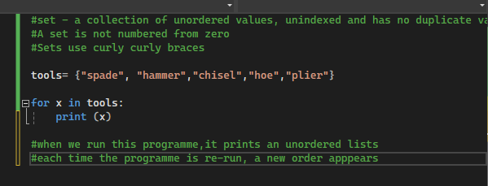

**Built in functions/methods for set**

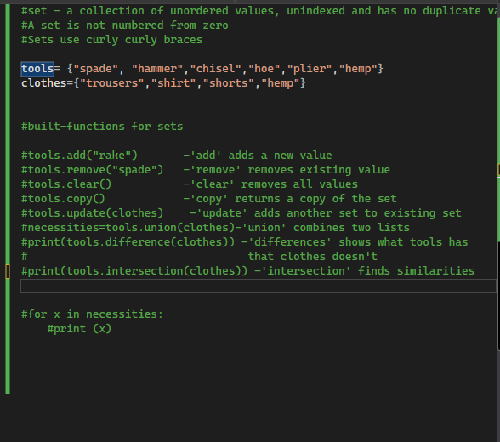

**Dictionaries**

**Dictionary –**stores changeable values which contains keys and values. Keys are words and values are definitions. The stored key:value pairs are not ordered(are not counted from zero). They are fast because they use hashing. They allow us to access values quickly.

**Syntax for dictionaries;**

**For key,value in (name of dictionary. items):**

**Print(key,value)**

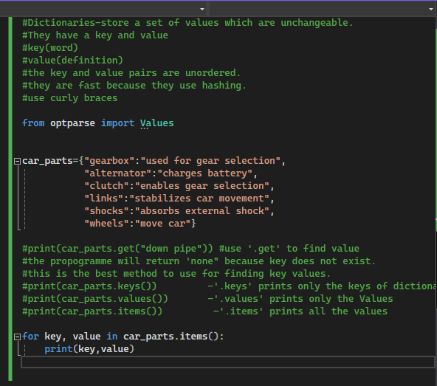

**Use ‘.get’ to find value of key**

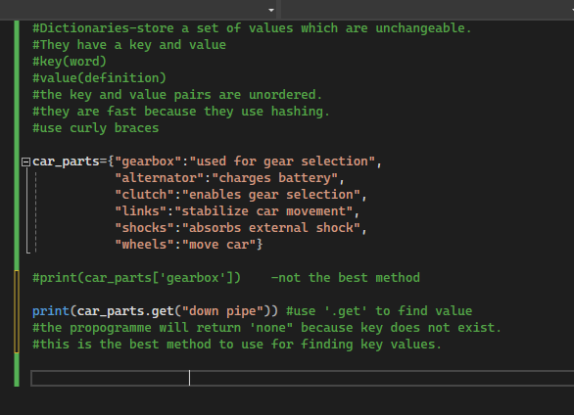

**Index operator**

**Index operator-** gives access to a sequence’s element (str, list,tuples)

-They are represented by [ ]square brackets

Syntax :

name of variable[element we want to access in value]

example:

day=”Monday”

when we want access the first element of value:

small_M=day[0].lower -This will turn the element into a lower case letter

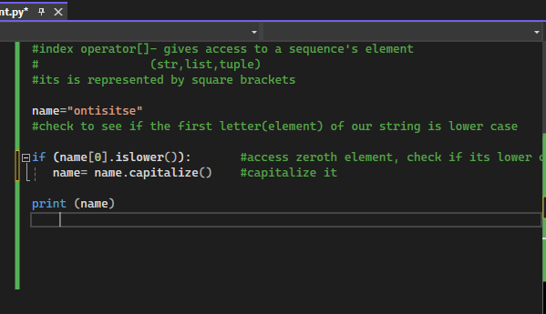

**Index operator methods**

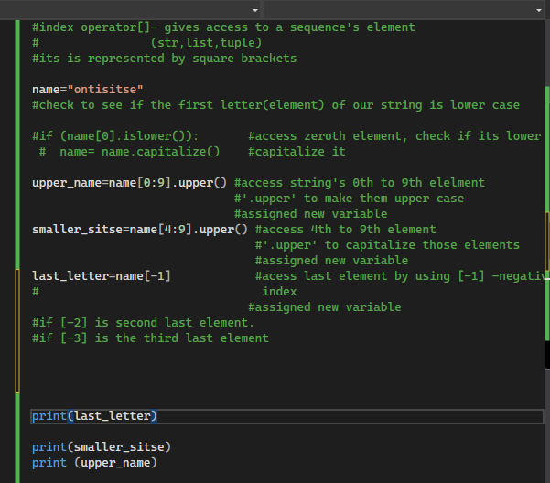

**Keyword arguments**

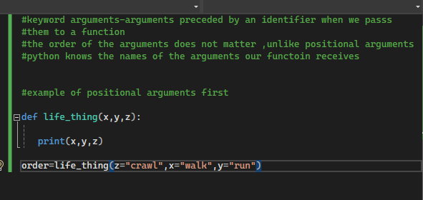

**\*args**

**\*args**  are used in functions for adding multiple arguments.

The most important aspect of this *args feature is the **asterisks(*).**  The asterisks is a multiplier.

We can use as asterisks and name it however we want , e.g. *more_cars, *names,*flavours,*numbers

Syntax for*args

Def add_numbers(*args):

p=0

for x(iteration in sequence) in args:

p=p+x

return p

p=add_numbers(67,67,878,45,34,465,5)

print(“The sum of these numbers is ,p)

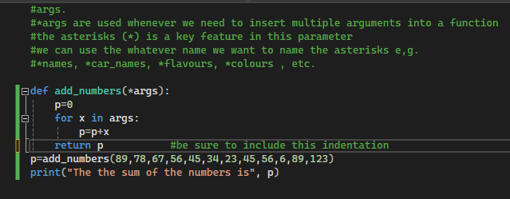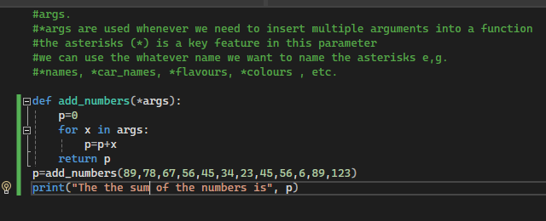

**Changing tuple into list and modufying the list parameters**

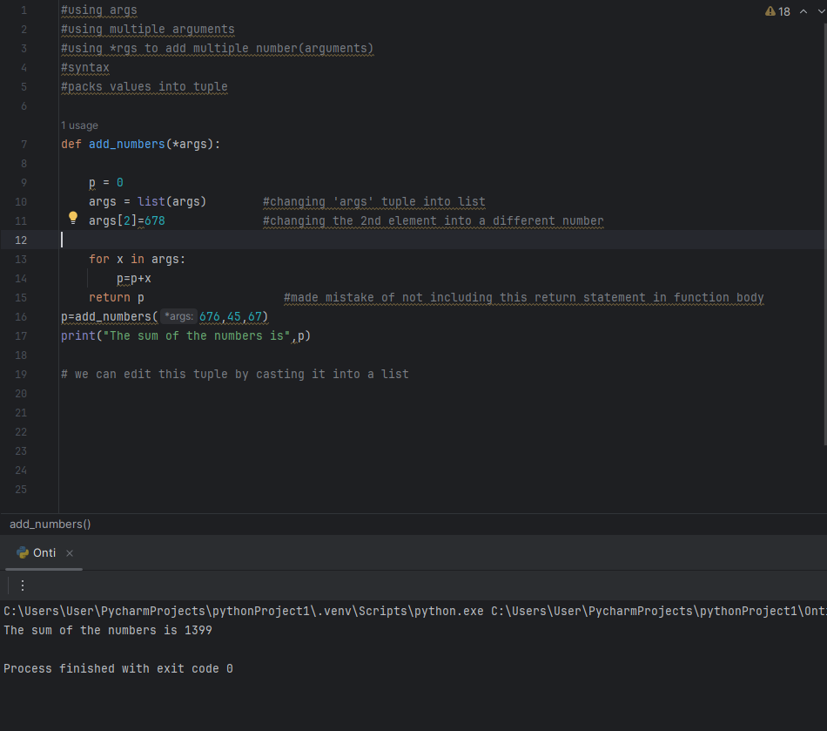

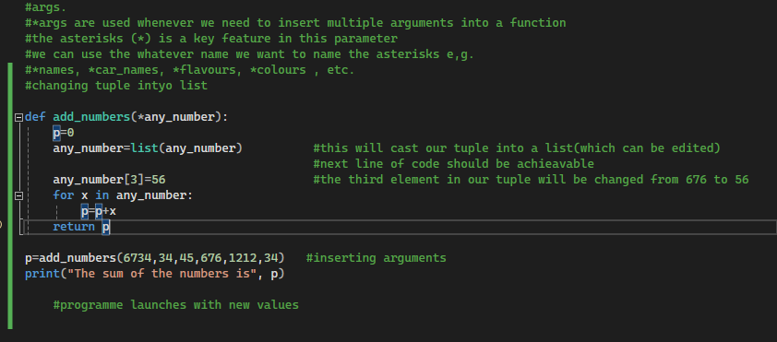

**\*\*kwargs**

**kwargs are used to pack all arguments into a dictionary.

-They are used for inserting multiple arguments into a function.

-Unlike, *args which use one *(asterisks) , **kwargs use two

-Again,the label ‘kwargs ’ isn’t important. The two asterisks are. You can name the variable as you like.

**Syntax for **kwargs:**

**For key,value in kwargs(name of the arguments):**

**Print(value,end=” ”)**

**We use end=”” to ensure our printed values come out in a straight line as opposed to a descending list.**

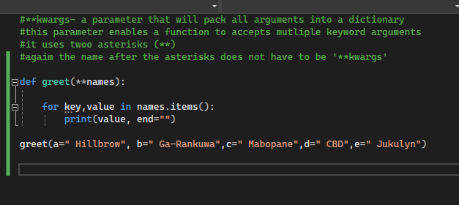

**str.format()**

**using the format method in strings.**

**Give user more control of the output they want to display.**

**Syntax for .format:**

**Variable 1=” Motho”**

**Variable 2=”batho”**

**Print(“{} ke motho ka {}”).format(variable 1,variable 2)**

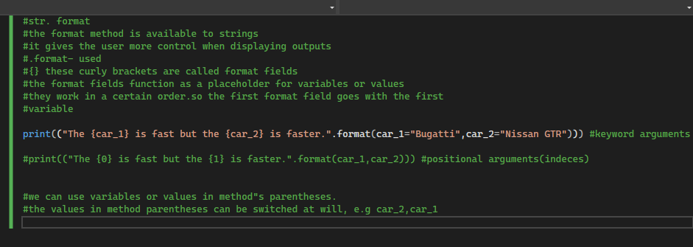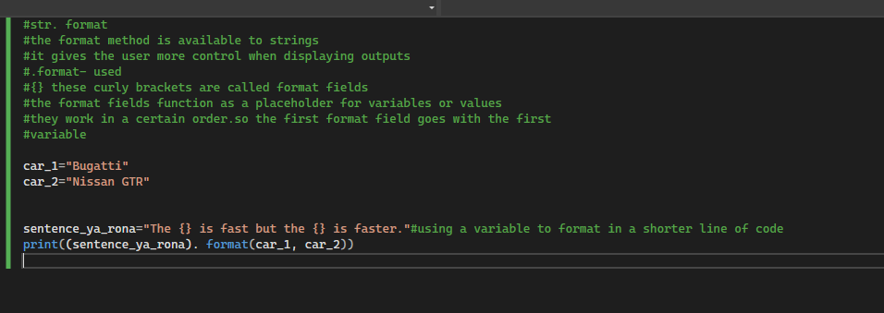

**Str.format()**

**using the string function method with padding.**

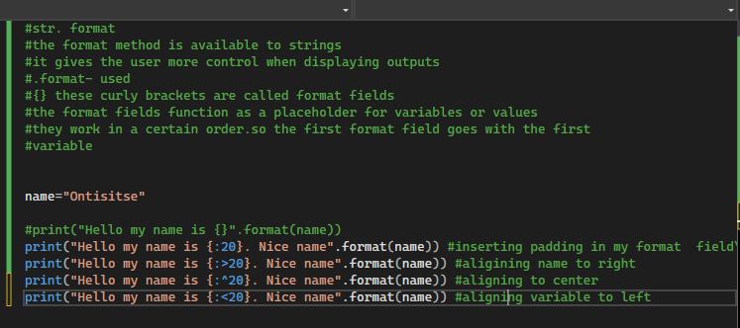

**str.format()**

**formatting numbers.**

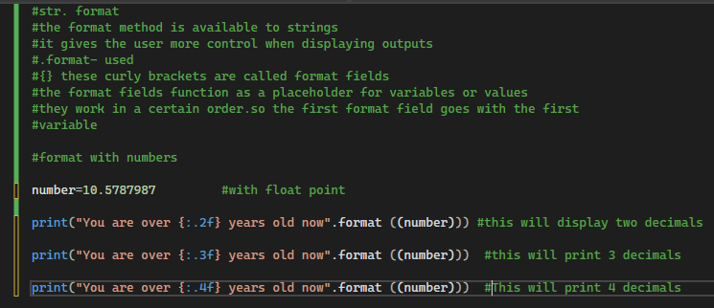

**Float**

**Str.format ()**

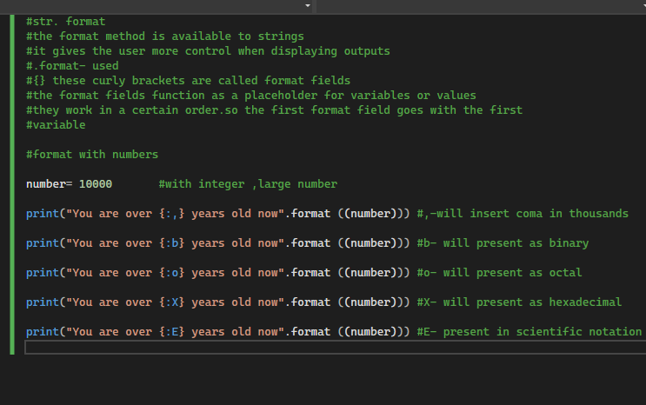

**integers**

**random module**

this random module is used to generate random values

**Syntax of random module:**

**Import random**

Before using the module, it is important to use the line **“import random”.** This allows us to access all features of the random module.

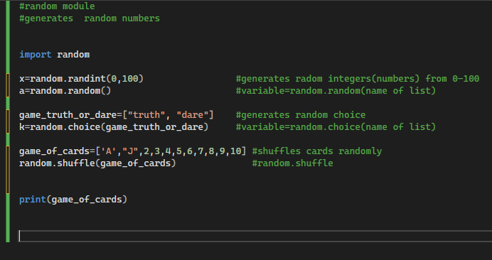

**Exception**

An **exception**  is an event detected during execution that will interrupt the flow of a programme.

**Example 1:**

A programme that adds two numbers and asks for user input for those numbers.The result is expected to be an integer but you enter you name in one of the input values.

The programme will throw an **EXCEPTION.**

Name of error**: ValueError**

**Example 2:**

**Dividing number by zero**

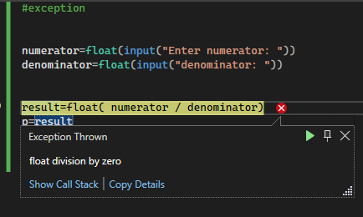

**ZeroDivisionError**

**Handling exceptions**

We can handle exceptions with the use of **“try:” and “except:”** blocks.

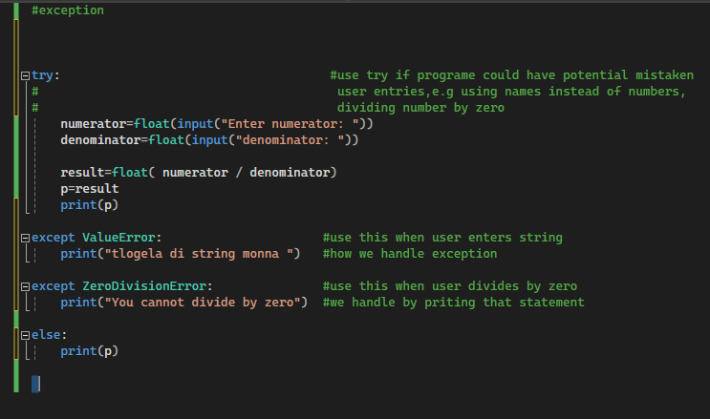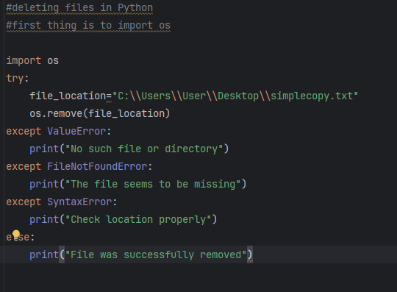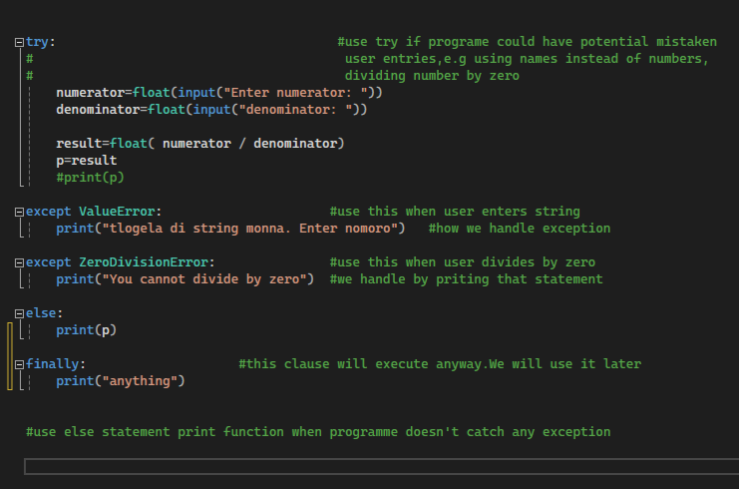

**Import os**

File detection.

In this programme, we are going to be locating a file in our system.

**Syntax for this:**

**Import os**

**My_file=(“C:\\User\\Users\\Desktop\\simple.txt”)**

**If os.path.exists(My_file):**

**Print(“File exists)**

**Else:**

**Print(“This file does not exist)**

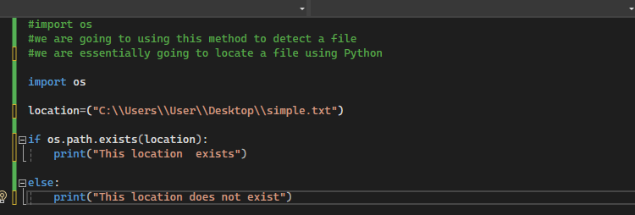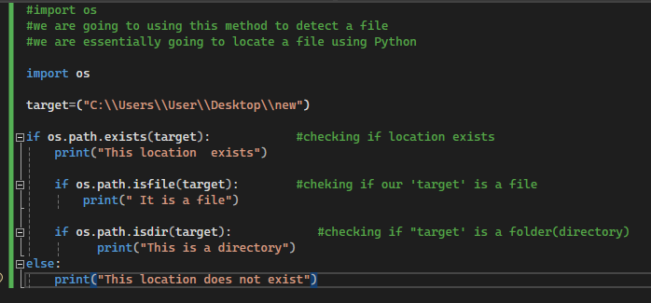

**With open**

We can use this to open a file and read it using Python

**Syntax for with open:**

**With open(“C:\\User\\Users\\Desktop\\simple”) as file:**

**Print(file.read())**

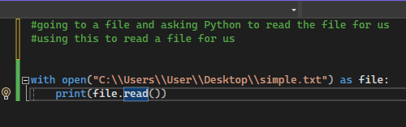

**Handling an exception for the with open feature:**

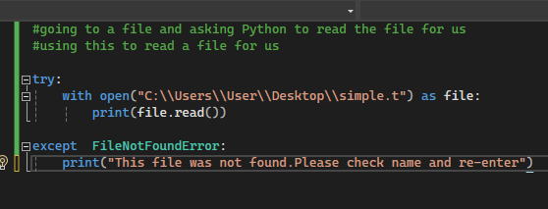

**Writing a new file**

We use this to write a file in python and store it in out computer

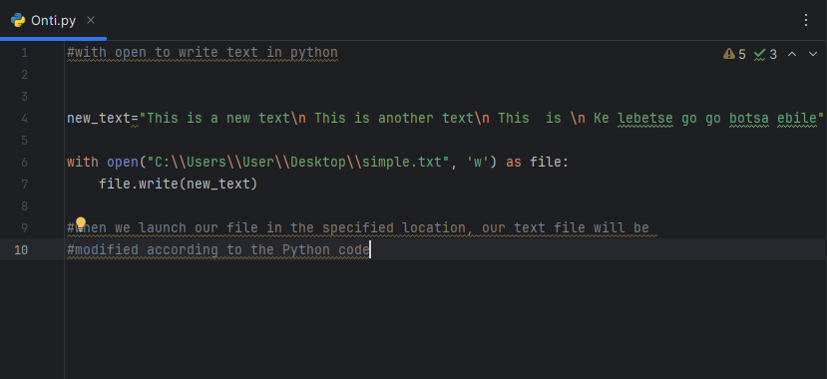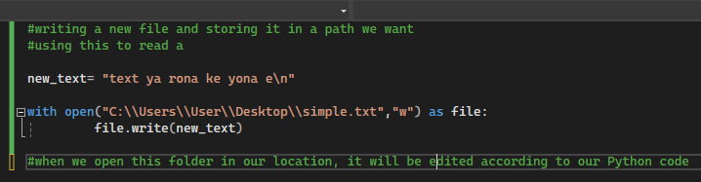

**We can append a text to the file that already exists**

By appending,we add new lines of text to our existing file.

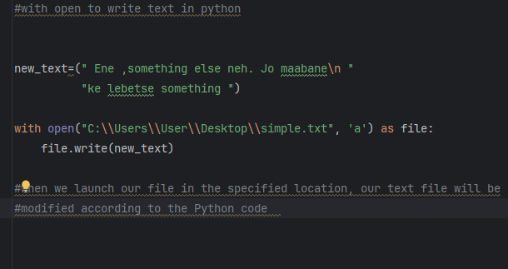

**Append, read, write**

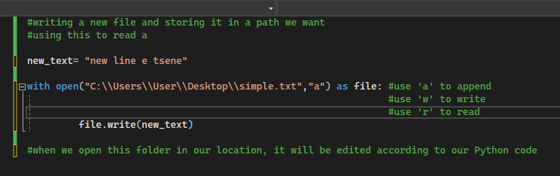

**Copying files in Python**

**Copyfile()-**This function copies the contents of a file

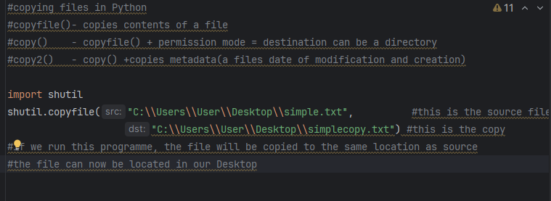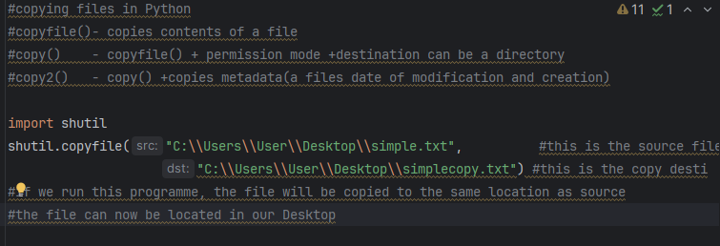

**We can choose between copyfile(), copy() and copy2(). It is, however, recommended to use copy() and or copy2().**

**Moving files in Python**

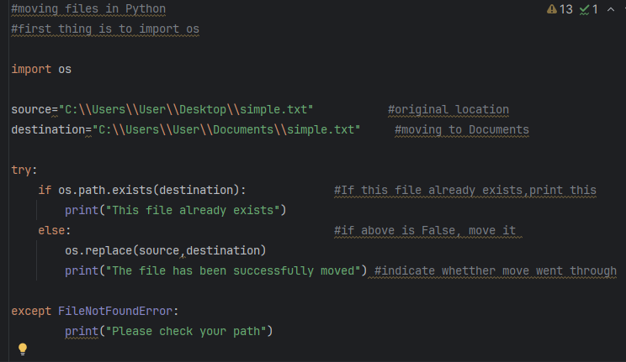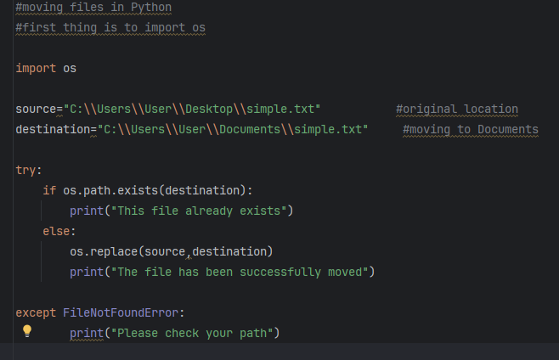

**Deleting files in Python**

**os.remove() -** removes files.

**os.rmdir() -** removes empty directory.

**shutil.rmtree() -** removes directories(folders) with contents in them.

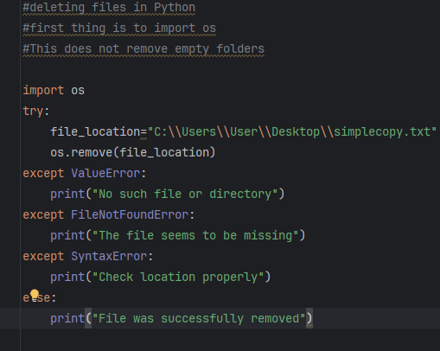

**There is a way to remove EMPTY folders since the above method only removes files.**

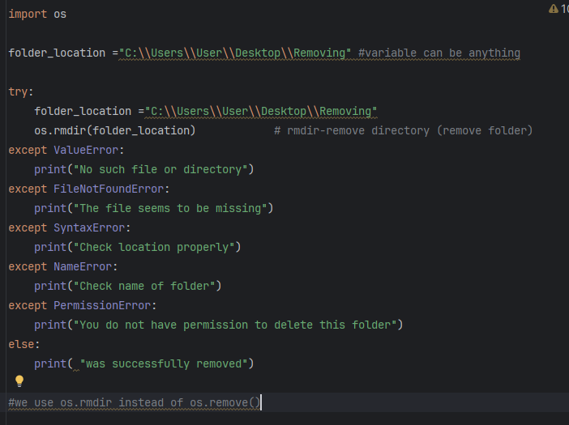

**Remove directory/folder with contents**

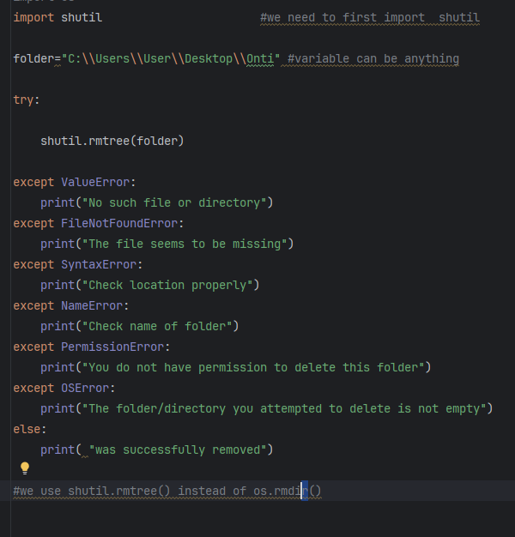

**Module**

**Module-**  a file containing Python code. It may contain classes, functions ,etc.

* It is used with modular programming which is to say a programme comprising of separate parts of blocks of code.

**We create a new module by creating a new Python file and naming it .**

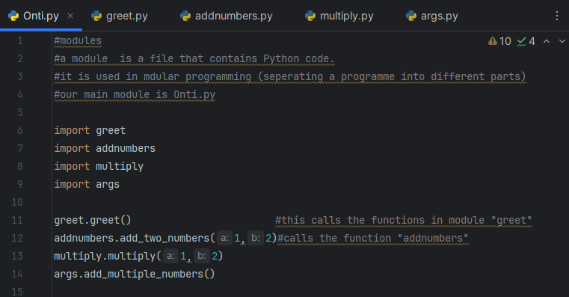

**At the launch of this programme, all the imported modules will be run.**

**List of the modules:**

**greet.py**

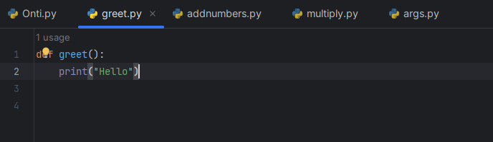

**Add numbers.py**

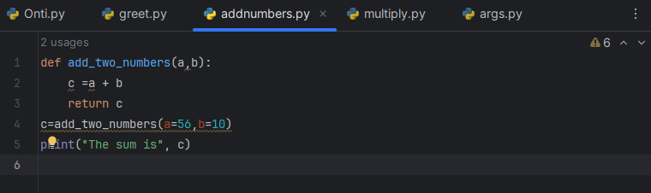

**Multiply .py**

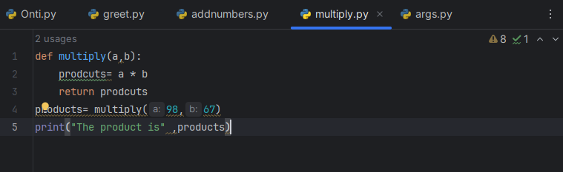

**Args.py**

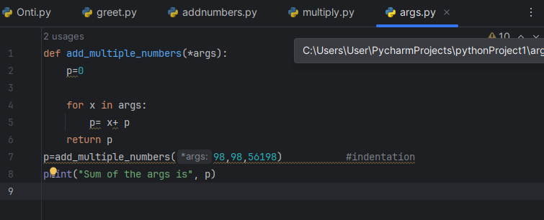

**List of built-in python modules**

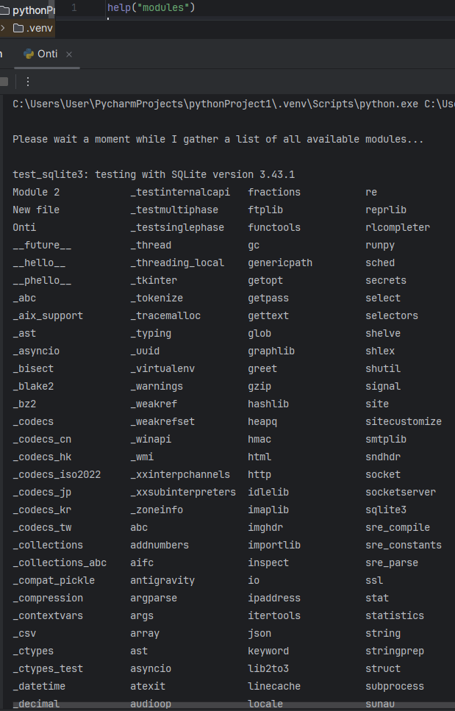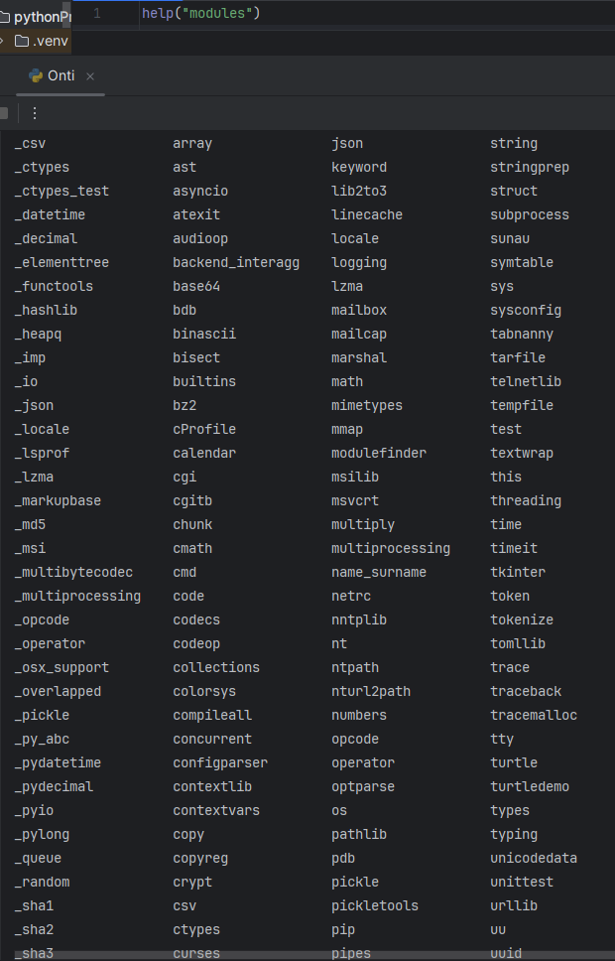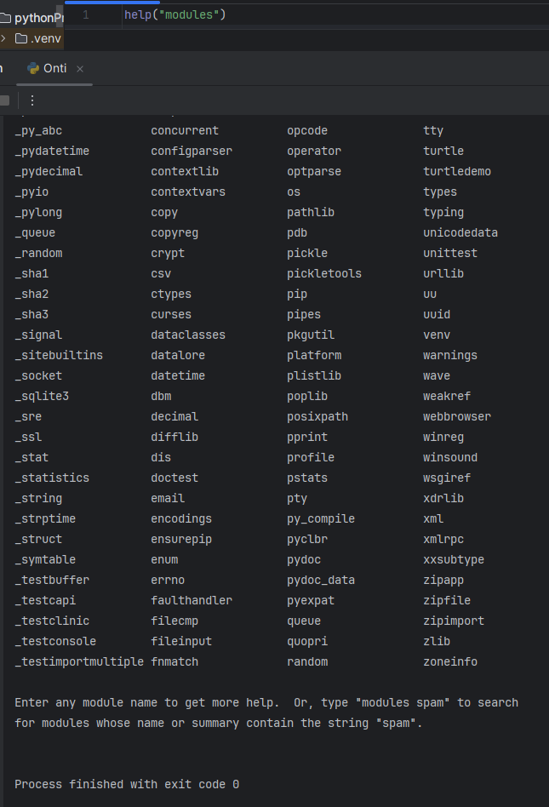

**CREATING A BASIC GAME OF ROCK ,PAPER SCISSORS.**

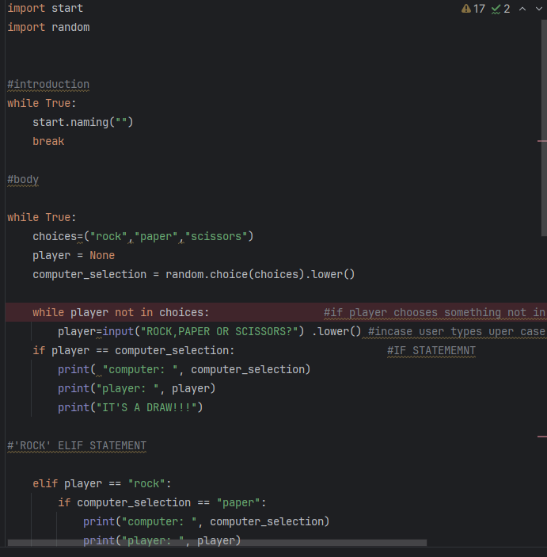

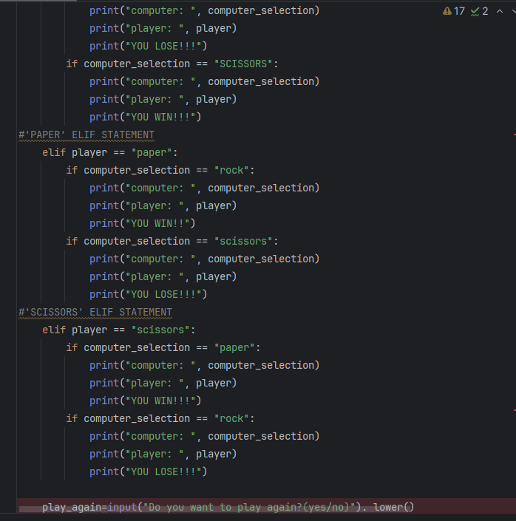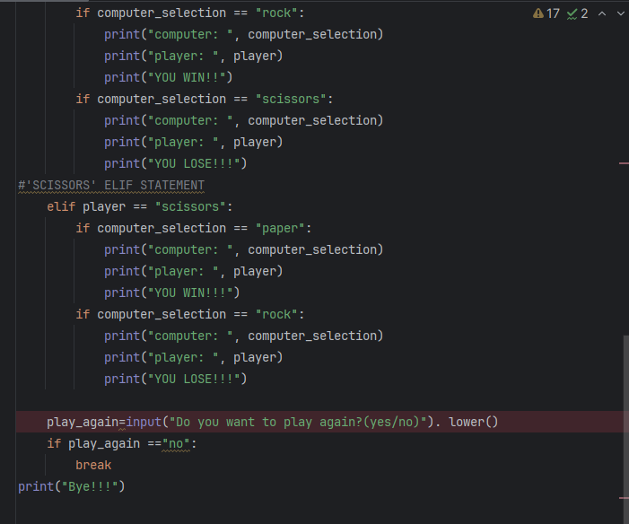

**CREATING A QUIZZ GAME**

**Code required to run a basic version of the game, comprising of if, else, elif statements, while loops, dictionaries, 2-D lists.**

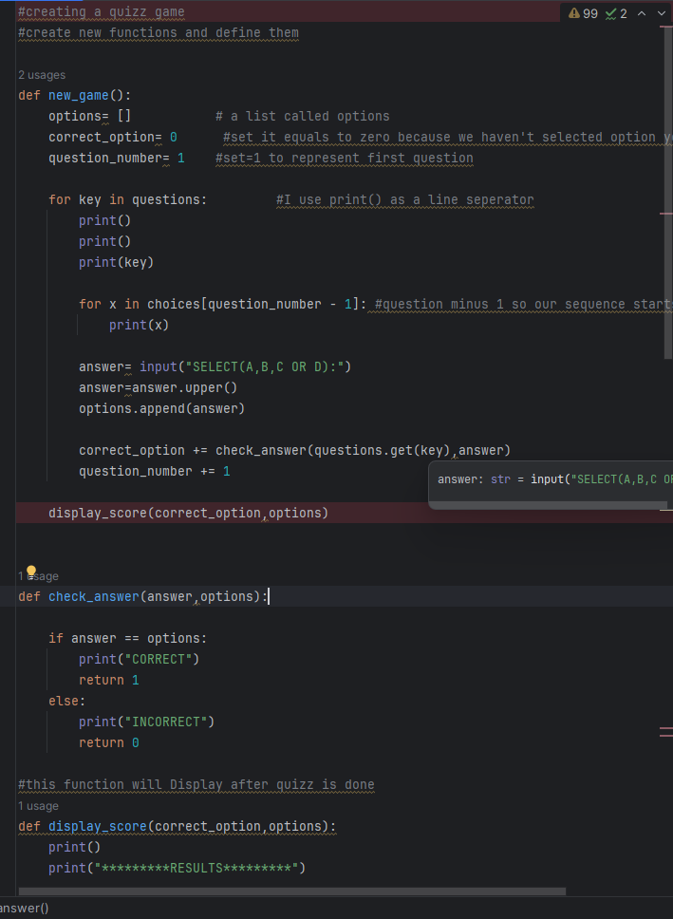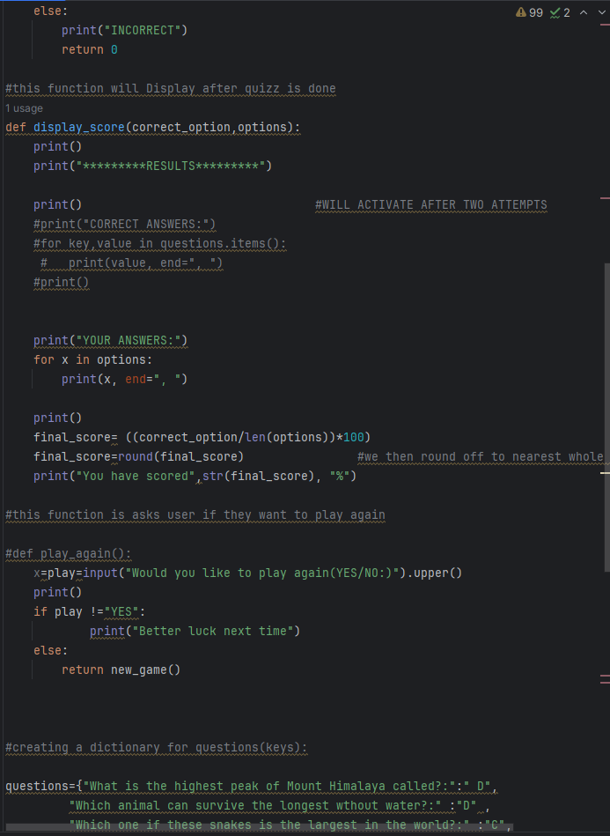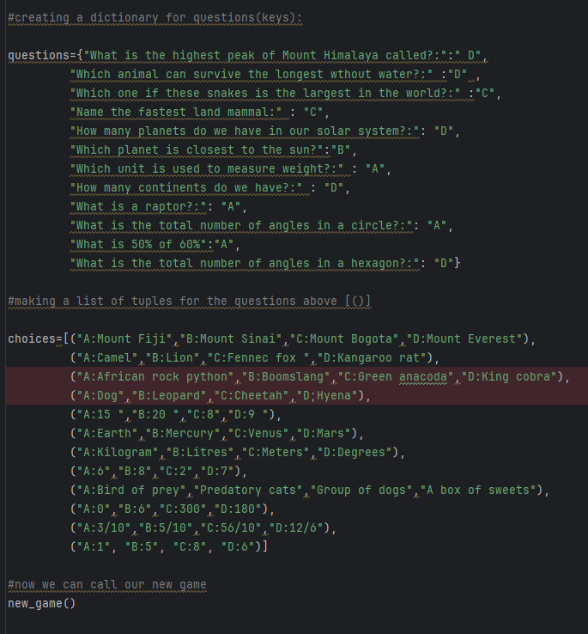

**OOP(Object Oriented Programming)**

**OOP is a programming language model that relies on building code around objects rather than on “action” and “logic”. This programming language focuses on being able to manipulate objects as opposed to creating the sequential logic used to manipulate them.**

**It is used in electronic devices to human beings and smartphone apps.**

**OOP allows data hiding which prevents accidental sharing of information across the code.**

**Classes**

**CLASS-**  A class is a blueprint, and idea of something. It is not a usable function but it describes how to make something. The blueprint/class can be used to create multiple objects. We can create a class using a class operator.

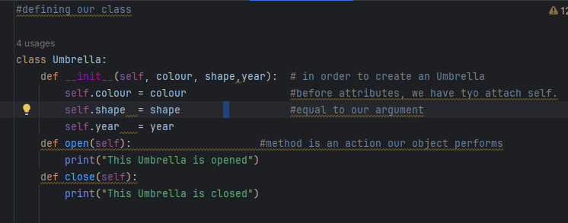

**\* def __ init__ (self, attributes) – init is short for ‘initiate’. This is our**

**contructor (We basically use it to create our object)**

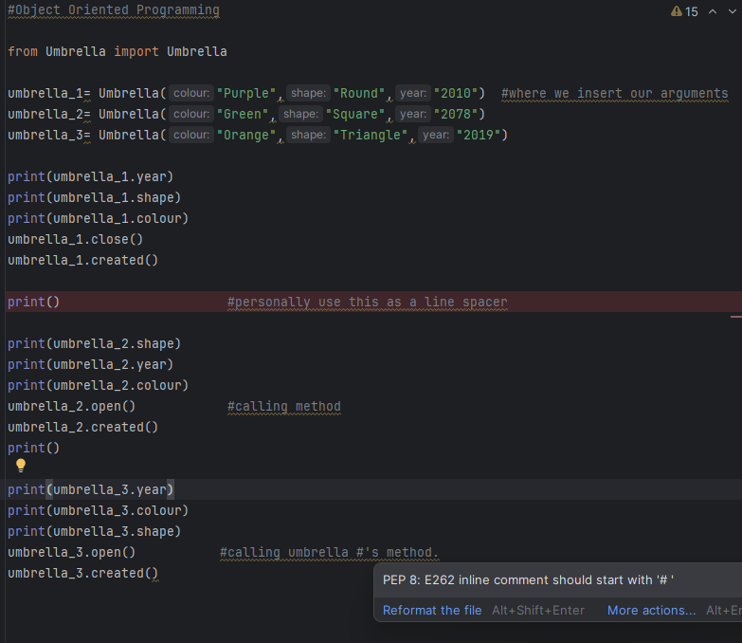

**Classes**

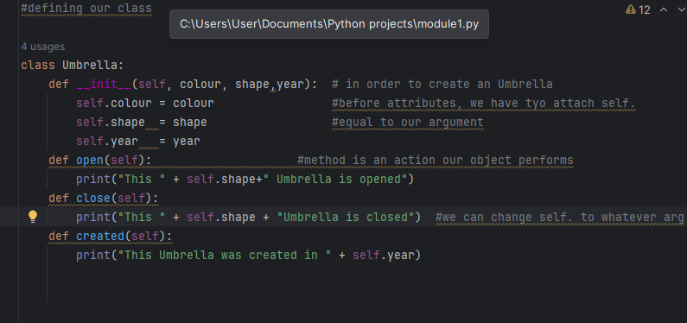

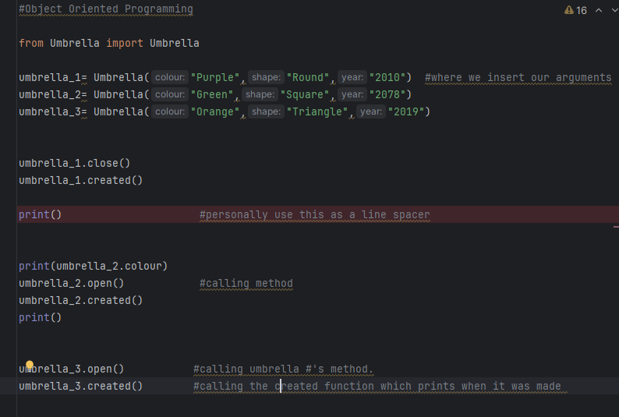

**Class Variables**

A **class variable** is declared inside our class but outside of our contructor.

An **instance variable** is declared both the class and constructor but specifically within the constructor

A class variable has a set value which becomes an attribute that applies to our objects by default.

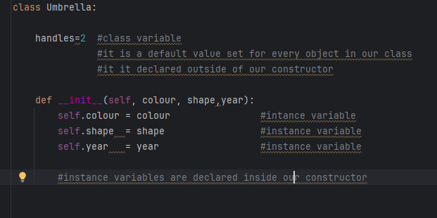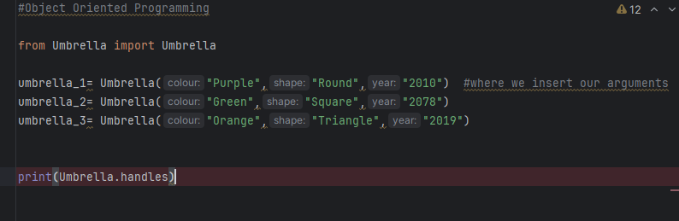

**Inheritance**

Classes can inherit attributes from other classes. These are known as **child classes.** Child classes have possess some of the parent’s (original class) attributes.

#Inheritance  
#parent and child classes  
#the parents class is the original class  
#the child class is the one that inherits attributes from the parent class  
#think of the child class like that of a humnaa child  
#the child inherits DNA from their parents so they have features which resembles those of  
#their parents but also have features of their own.

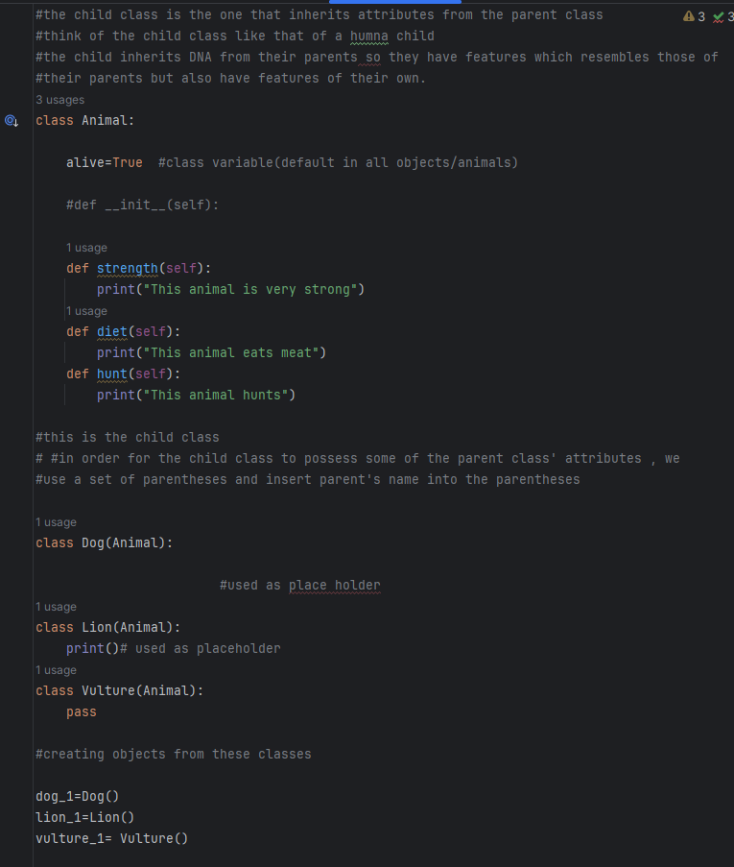

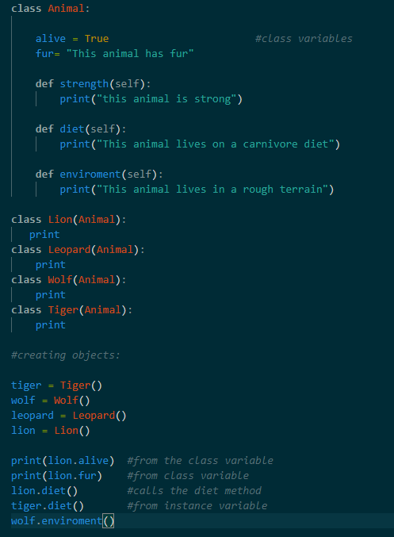

**Inheritance with unique attribute added to one child class**

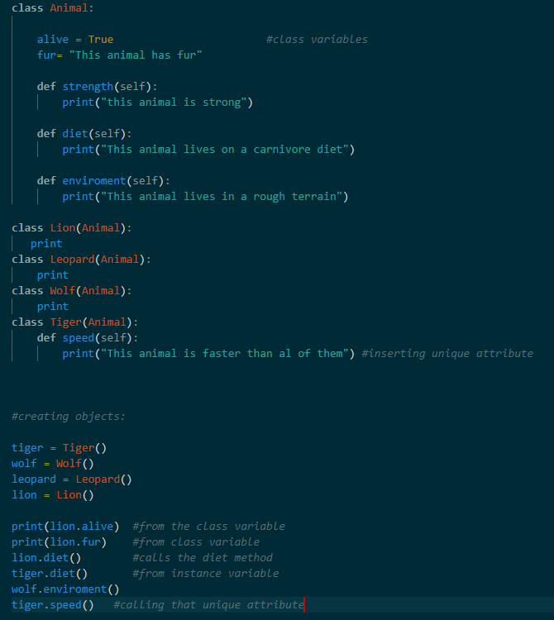

The tiger inherits all the attributes of the parent class but also has a unie set of features/attributes.

**Multi-level inheritance**

**Multi-level inheritance-** This is where the one derived(child) class inherits attributes from another child class.

**Multiple inheritance**

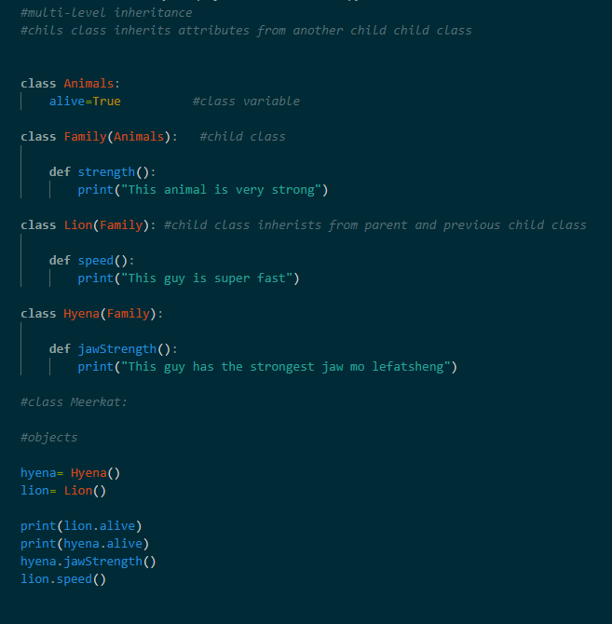

**Multiple inheritance-**  In this instance ,the sub class/ child class inherits some attributes from one of the parent classes.

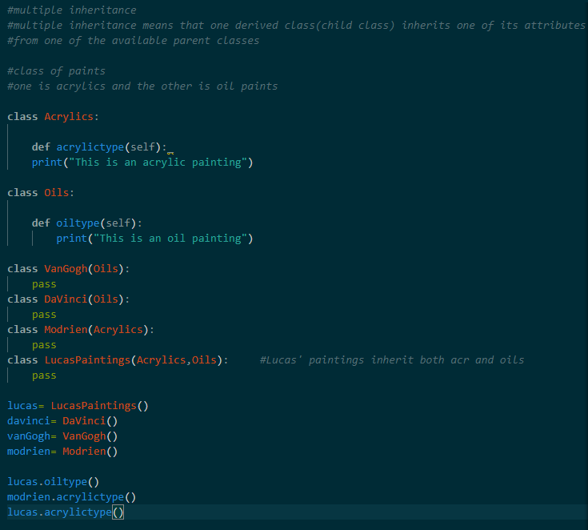

**Method overriding**

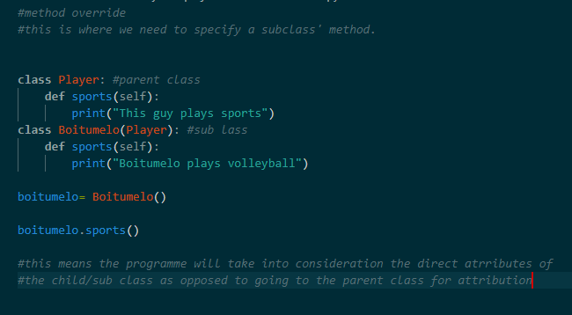

**Method chaining**

**Method chaining-**method chaining calls multiple methods sequentially.

* Each call performs an action on the same object and returns self

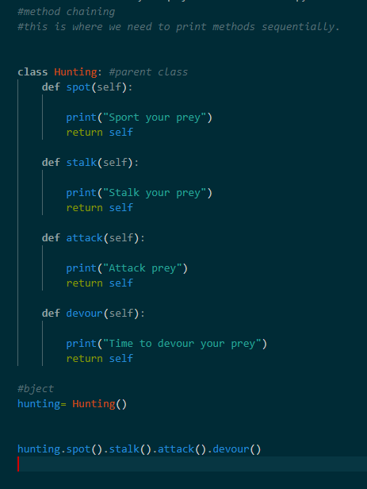

**Super()**

**Super() function –** used to get access to the methods of a parent class. It returns a temporary object to parents class when used.

We can utilize this function when child/subclasses have the same attributes.So instead of writing attributes individually in the child classes,we can instead write them in the parent class and use the super() function in the child classes to get access to the parent classes attribute which is similar in all the child/subclasses.

**Syntax for super()**

**super(). __init__(parameters)**

**We do not insert ‘self’ in the super() function parentheses.**

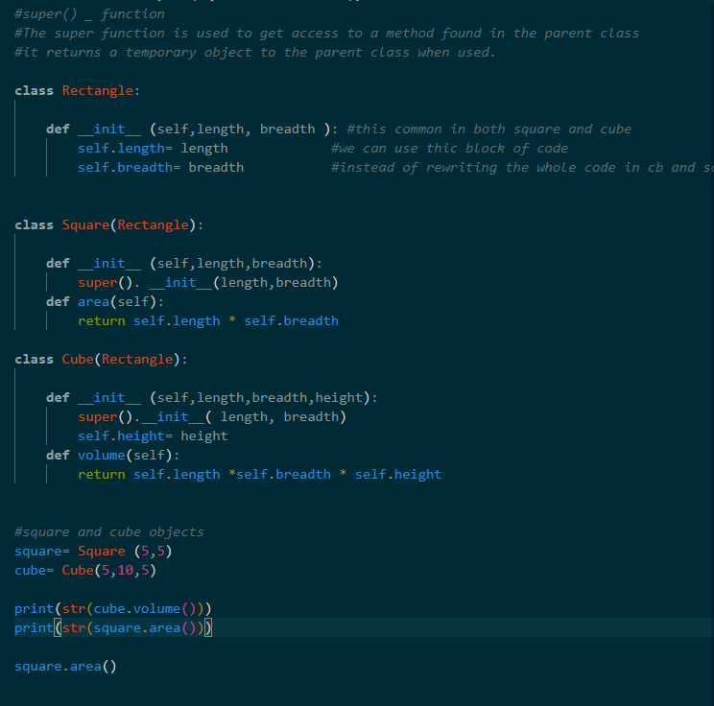

**Abstract classes**

**Abstract classes-**  used to prevent the user from using the parent class as an object. They are used for declaring the parent’s attributes but these sttributes cannot be used as implementation. This means we can see their declaration but cannot perform a task with them unless we override them in the child class by assigning a an output(e.g print()).

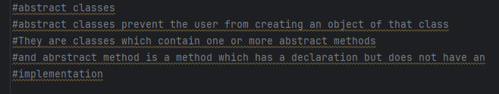

**Syntax for abstract classes**

**Import abc from abstractmethod (Pycharm)/asbtractclassmethod(VS code)**

**@abstractmethod**

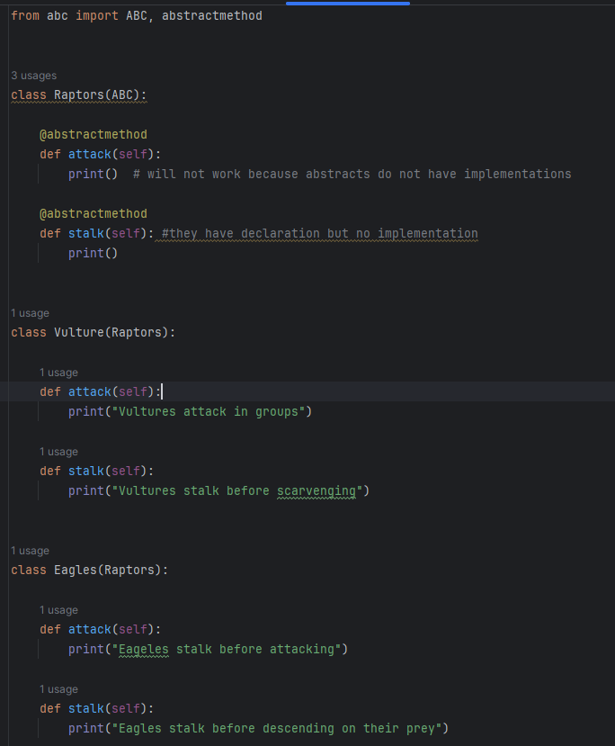

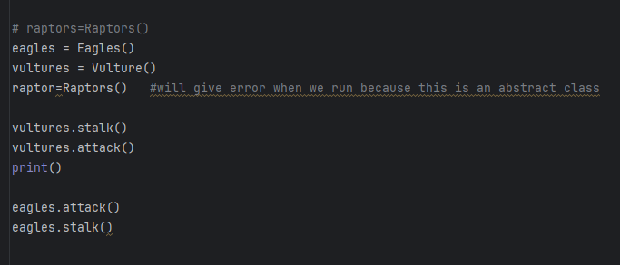

By creating an object for the parent class, which is abstract, the rpogramme will give a type error because abstract classes cannot be implemented.

**Passing objects as arguments**

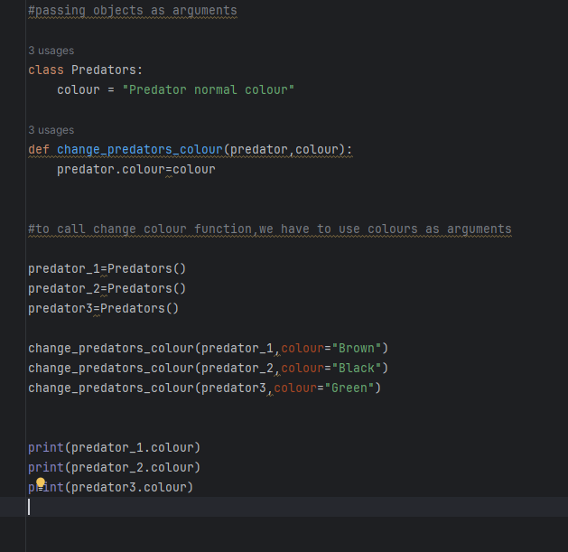

**Duck typing**

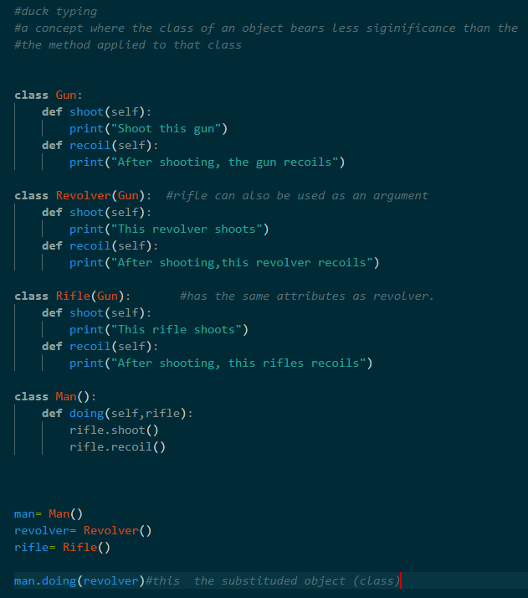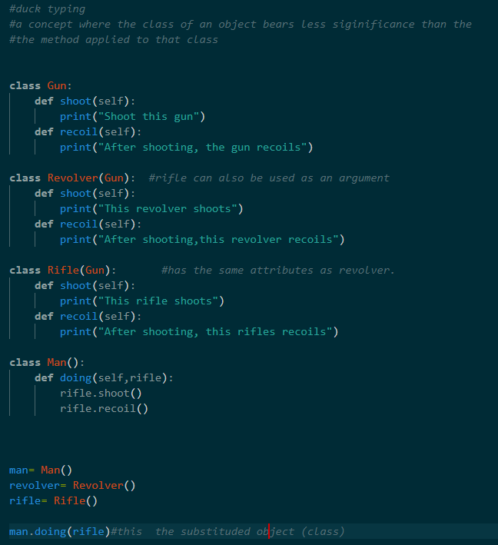

**Assigning a function to a variable**

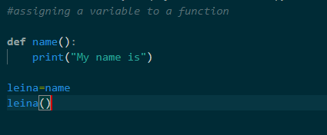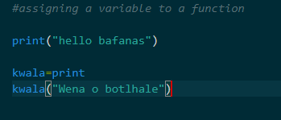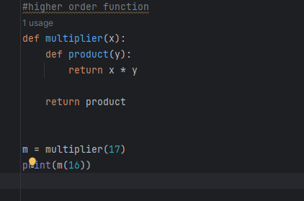

**Higher order function**

**Higher order function-** a higher order function is a function that accepts a a function as an arguments.

It can also return a function

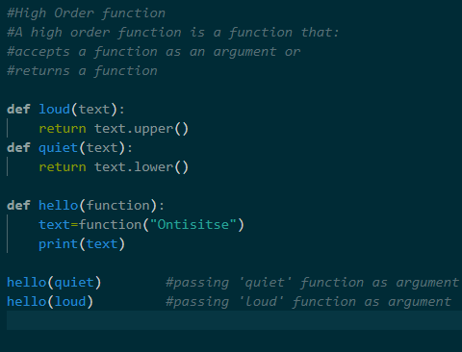

**Lambda functions**

**Lambda function-**  A lambda function is similar to a user-defined function except it uses only one line. It does not have a name. Lambda functions are often referred to as anonymous functions. They are an efficient way in whihch one can write a function that will contains a simple expression(single line statements).

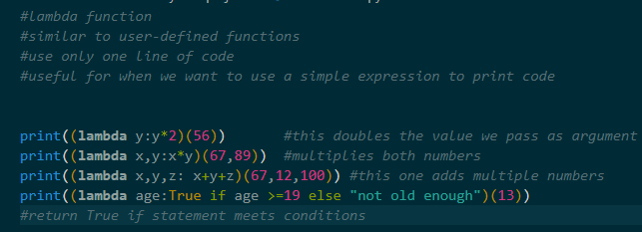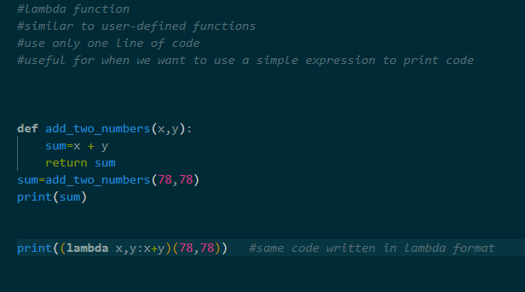

**Sort () method and sort() function**

This method/function is used to sort data alaphabetically. It can also be used to sort data in reverse provided a key is provided for such a scenario.

**Sort () method** -used with lists

**syntax for sort() method:**

**name of list.sort()**

**for x in name of list:**

**print (x)**

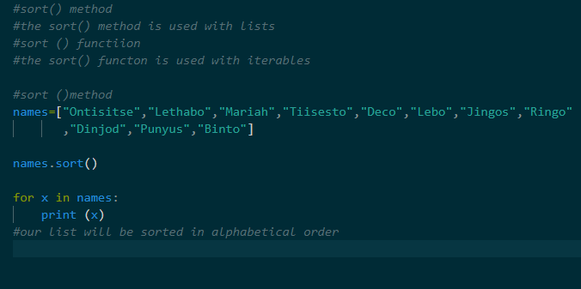

**Syntax for sort () method. In reverse**

**Name of list. sort (reverse=True)**

**For x in name of list:**

**Print (x)**

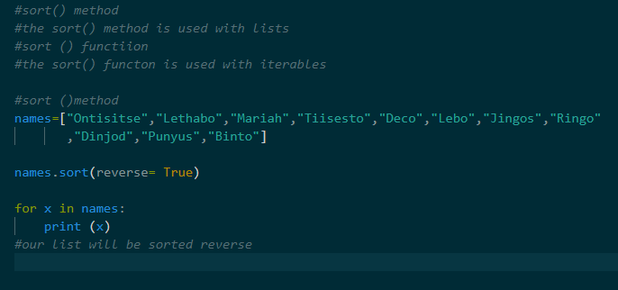

**sort() function**- used with iterables

**syntax for sort() function:**

**sorted_name of list=sorted(name of list)**

**for x in sorted_name of list:**

**print (x)**

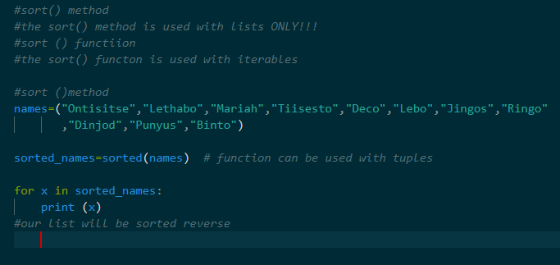

**sorting list in marks’ order**

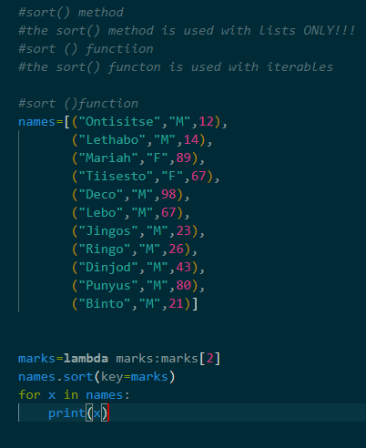

**Syntax for sort() function in reverse**

**Sorted_name of list=sorted(name of list,reverse=True)**

**For x in sorted_name of list:**

**Print(x)**

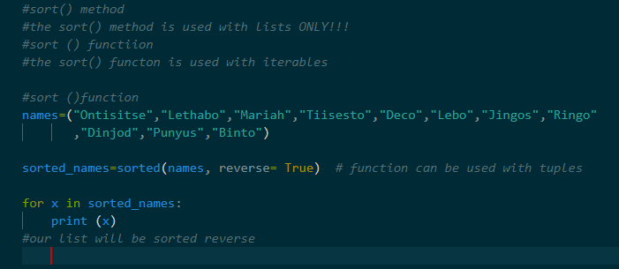

**Map() function**

**Map() function-**  this is a function that works as an iterator to return a result after applying a function to every item of an iterable(tuples,lists,etc).

-It is used when you want to apply a single transformation function to all the iterable elements.

-It accepts two arguments(function, iterable)

**Syntax for map () function:**

**Variable=map(function , iterable(name of list or tuple))**

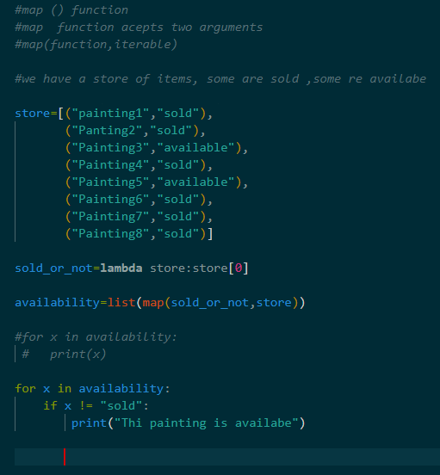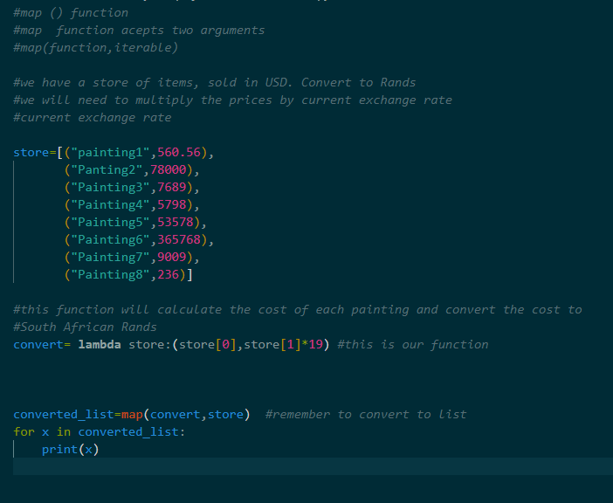

**Filter() function**

Filter function- This function creates a collection of elements from iterable for which a function returns true.

**Syntax for filter() function:**

**filter(function,iterable(list or tuple))**

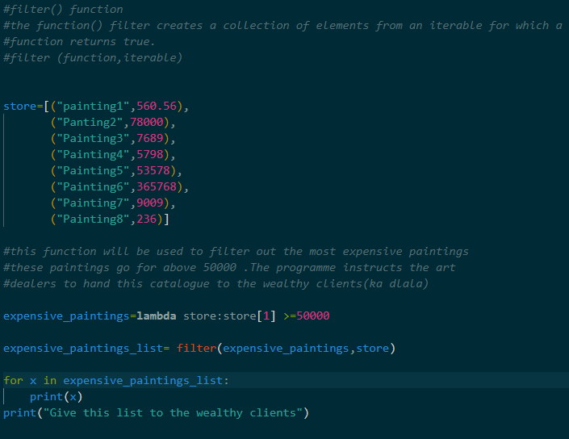

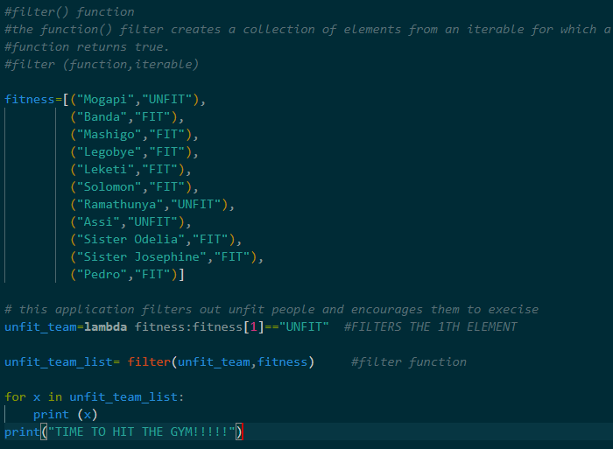

**Reduce() function**

**Reduce function-** applies a function of our choosing to an iterable and reduces that iterable to a single cumulative value. It performs function on first two elements and repeats process until 1 value remains.

**Import functools**

**-----------------**

**Syntax for reduce() function:**

**reduce(function, iterable)**

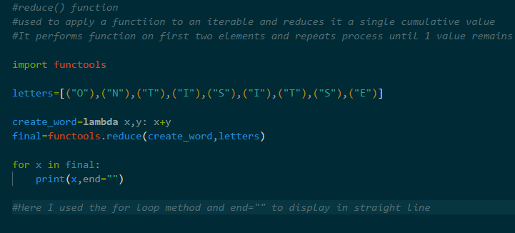

**We can use a list of tuples when listing letters ONLY.**

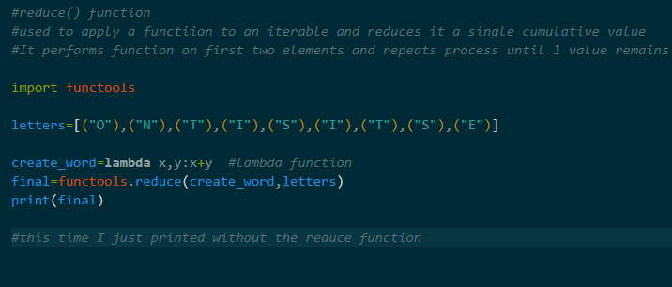

**the following are for adding and multiplying until we get one cumulative value.To print our results,we do not use the for-loop statement.**

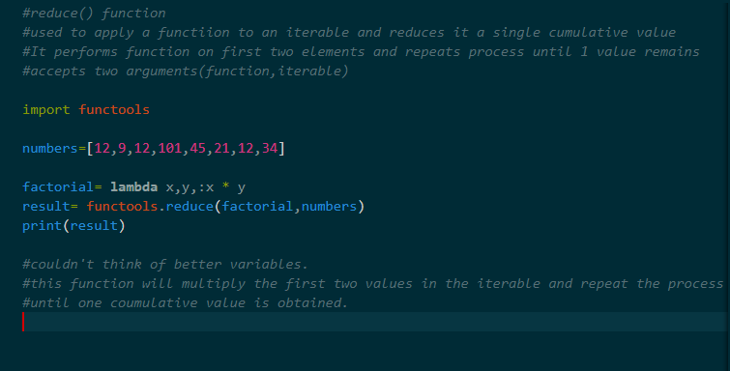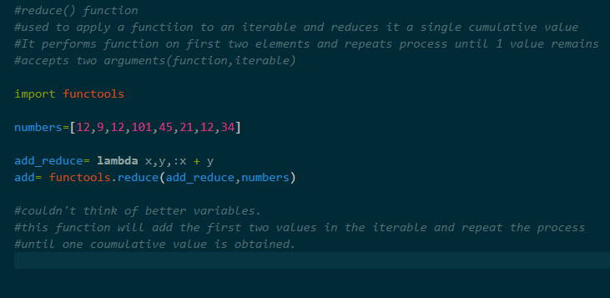

**the following are for adding and multiplying until we get one cumulative value.To print our results,we do not use the for-loop statement.**

**list comprehension**

**list comprehension-** This is a way to create a list with less syntax. List comprehension can mimic certain lambda functions and is easier to read.

A way, really, to create a function using an expression. Like Lambda.

**Syntax for list comprehension for if condition**

**List =[expression for item(x) in iterable]**

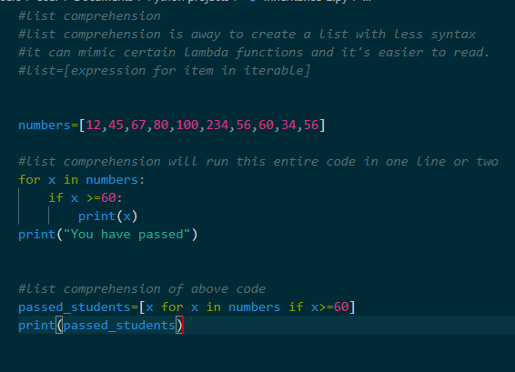

**Syntax for list comprehension for if else condition:**

**List=[x if x>=10 else “Failed” for x in numbers] -example**

**List=[entry if expression else “print statement” for entry in name of list]**

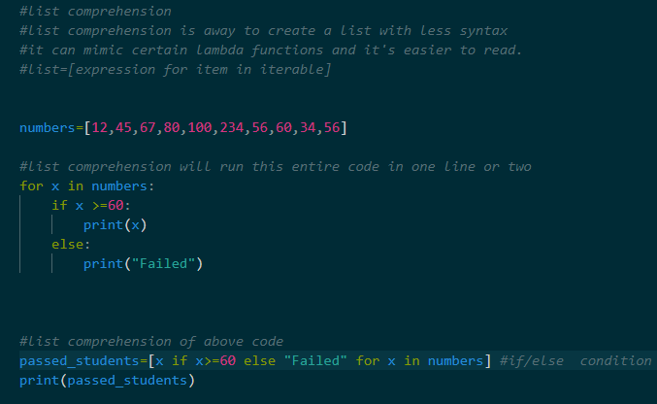

**Dictionary comprehension**

**Dictionary comprehension-** used to create dictionaries using an expression.

It can replace for loops and certain lambda functions.

**Syntax for dictionary comprehension:**

**Dictionary= {key: expression for (key, value) in iterable}**

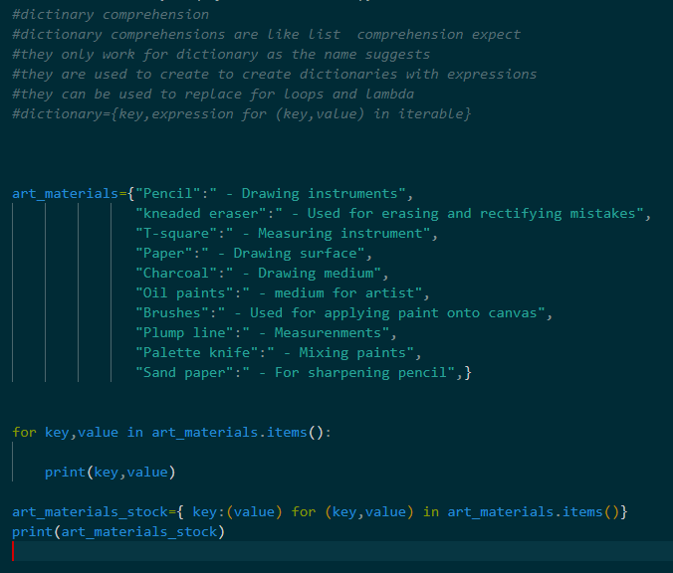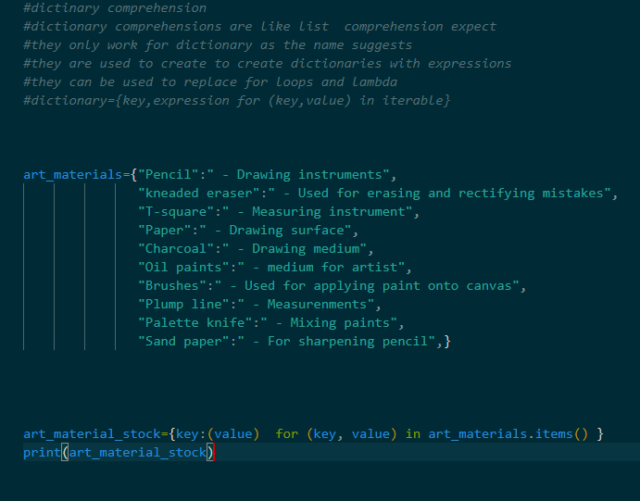

**Dictionary comprehension using if statement**

**Syntax for dictionary comprehension for if statement:**

**Example:**

**Dictionary={key: ( value ) for (key,value ) in car_parts.items() if value>= 200}**

**Print(dictionary)**

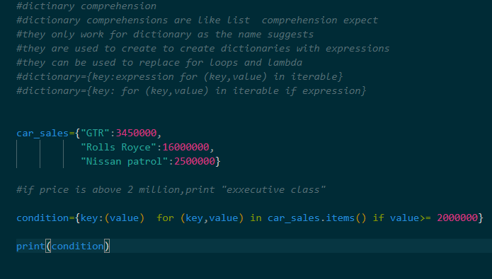

**Dictionary comprehension with if_else statement**

**Example:**

**Syntax for if else statement:**

**Dictionary={key: (“expensive” if value>= 2000000 else “affordable” ) for (key,value) in car_sales.items()}**

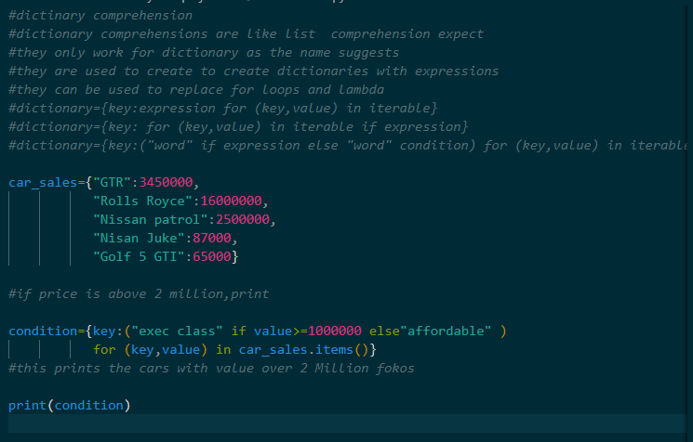

**We can also pass in a user_defined function to create the if elif statement condition**

**Syntax for this will look like this:**

**Dictionary={key: (function name(value)) for (key,value) in car_sales.items()}**

**Again, parentheses after “key:” are optional. I just use them as placeholder, so as not to get confused.**

**Zip() function**

**Zip() function-** aggregates elements from two or more iterables (lists, tuples, etc). Created a zip object with a pared elements stored in tuples for each element.

Combines the first elements in two different tuples and returns the pair of those elements. It then repeats this process for the second element.

**Syntax for Zip:**

**Variable= zip( iterable, iterable)**

**Print(variable)**

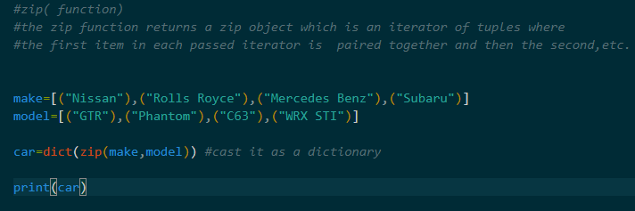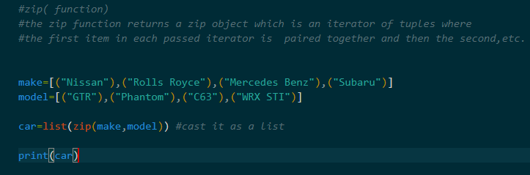

**Using for-loop to display the zip function**

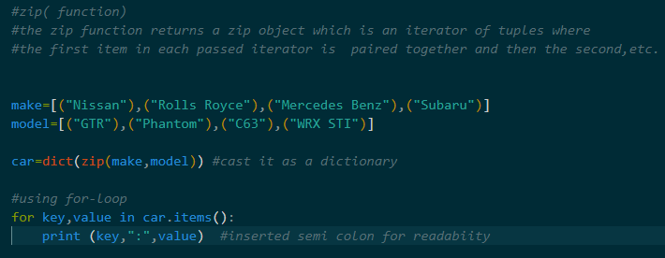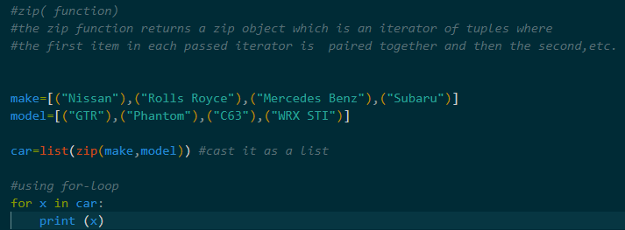

**Use of if __name__ == “__main__” in Python**

**“__main __” is a value that represents the name of the top level environment,where top level code runs.**

**“if name == main ,then we run our programme.otherwise.This is just a library” _ a saying.**

This helps us establish from which module we are running our code. It helps us differentiate between main module and the secondary ones.

It allows our modules some flexibility. Our module can either be run as a standalone programme or used as an import.

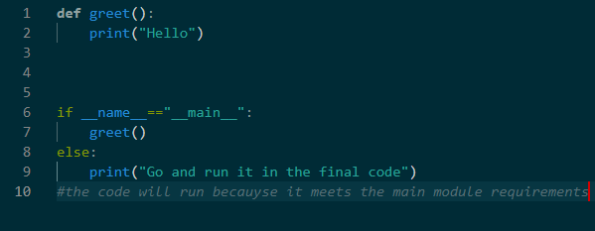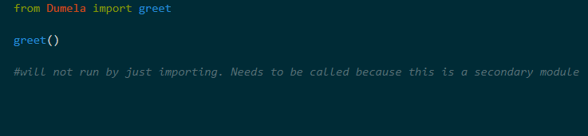

**Use of the time module in-depth**

**1.Epoch- a date and time from which a computer measures system time .**

**2.Epoch- in computing , and epoch is a fixed date and time used as a reference from which a computer measures system time.**

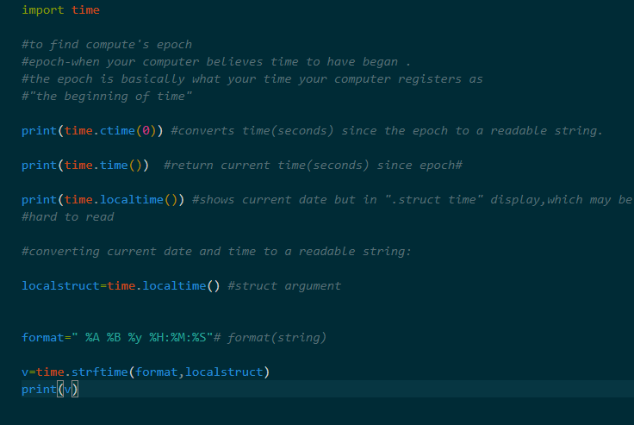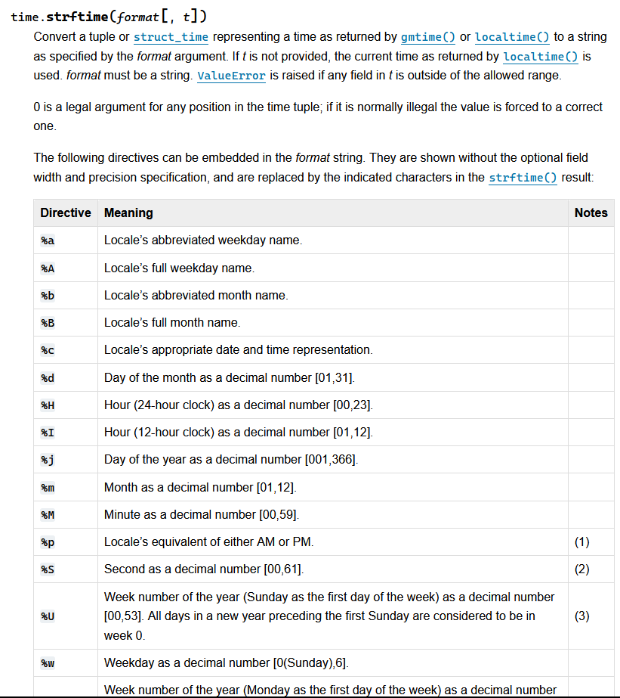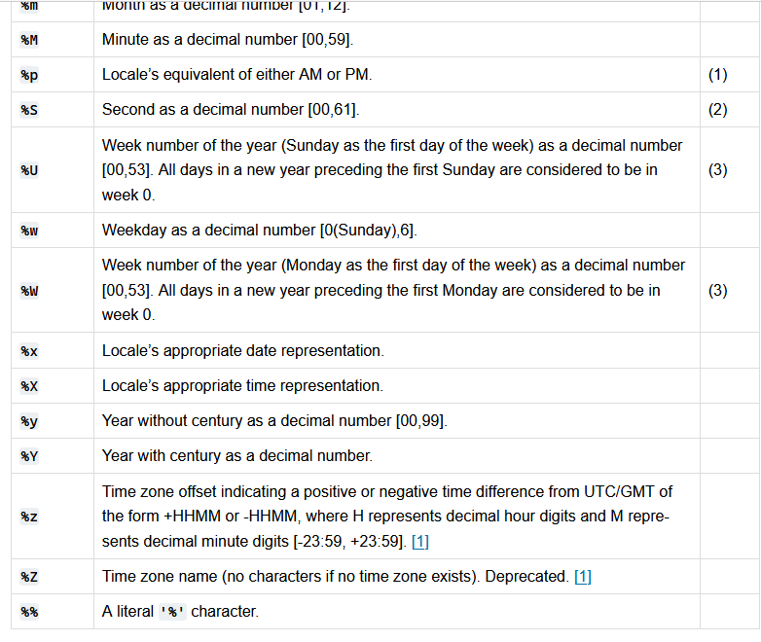

**Threading**

**Threading allows our programme to have different parts of our process running concurrently.**

**Thread-**a flow of execution. Like a separate orderof instructions.However each thread takes a turn running to achieve concurrency

**GIL-** Global interpreter Lock allows only one thread to hold the control of the Python interpreter.

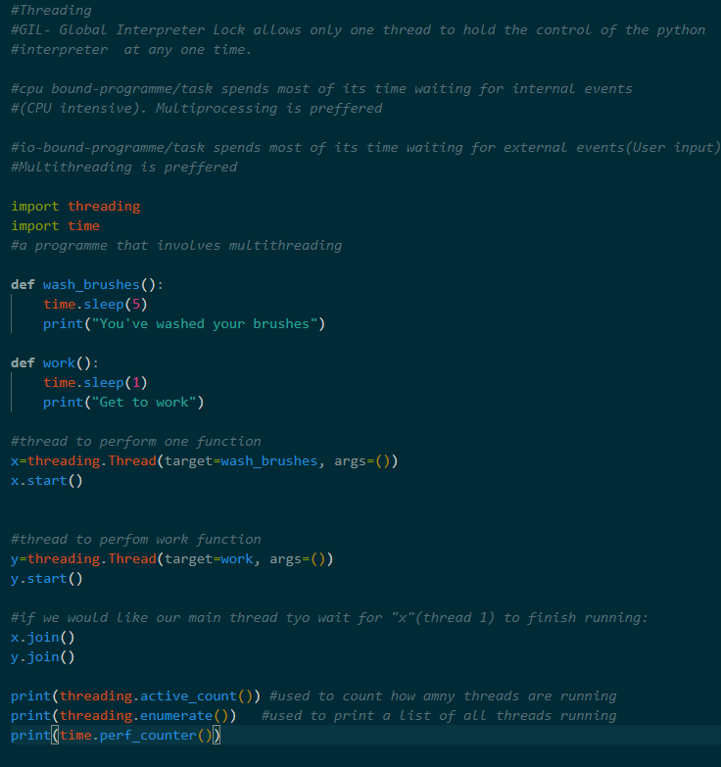

**Daemon thread**

**Ddaemon thread-**  a thread that runs in the background, not important for programme to run.

Programme will not wait for daemon threads to run before exiting.

**Non-daemon threads** cannot normally be terminated , they stay active until task is complete

**Examples:**

**Garbage collection, background tasks, waiting for input, long-running processes.**

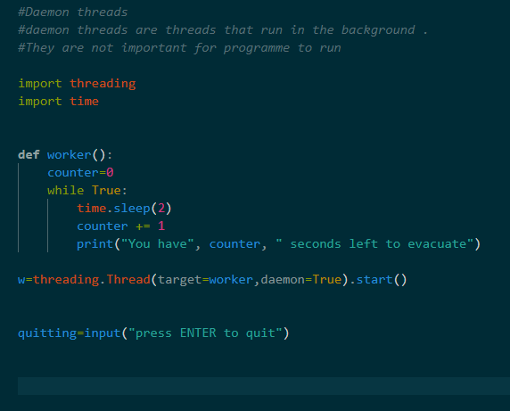

**Multiprocessing**

**Multiprocessing** allows us to write concurrent programmes by bypassing the GIL (Global Interpreter Lock).

It allows us to run programmes in parallel as opposed to just concurrently (waiting for a sequential launch) like we would in multithreading.

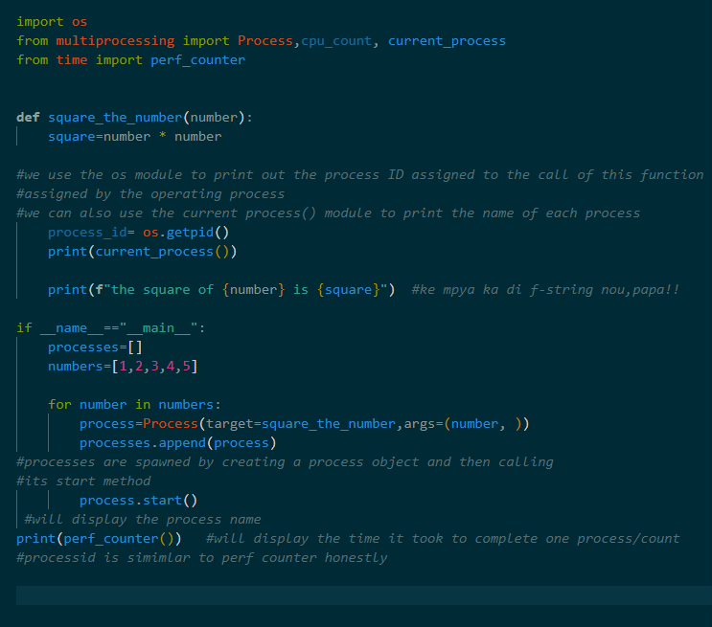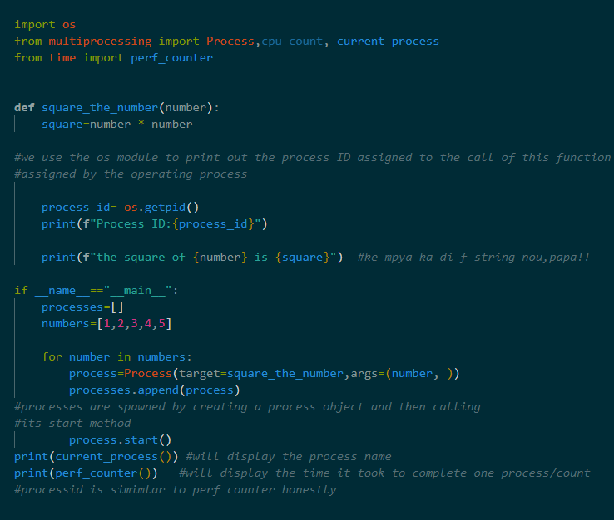

**F string (Functional string)**

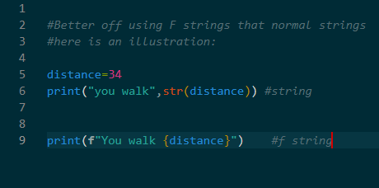

**GUI - GRAPHICAL USER INTERFACE**

**GUI-** a digital interface in which a user interacts with graphical components such as icons, buttons and menus. In a GUI, the visuals displayed in the user interface convey information relevant to the user, as well as actions that they can take.

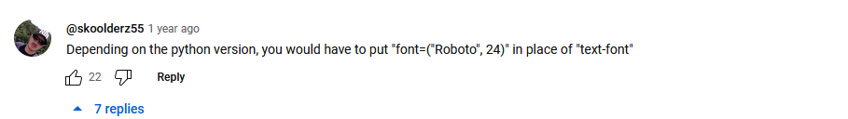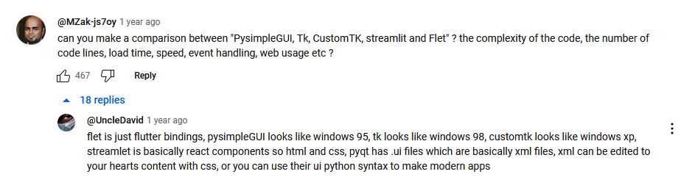

**Widgets-** GUI elements: buttons, textboxes, labels, images

**Windows-** Serve as a container to house widgets.

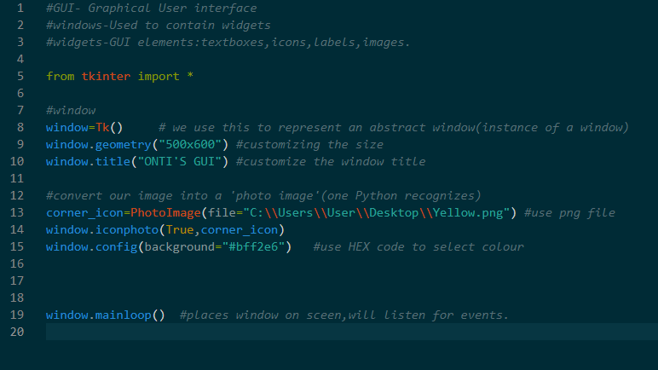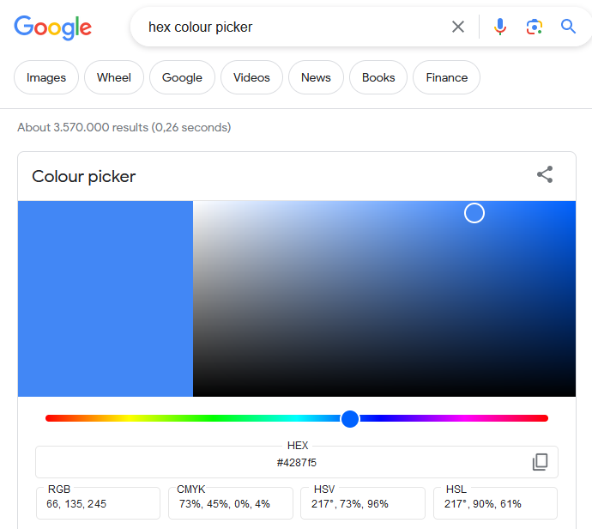

**This is my first GUI window and corner icon with a different background colour.**

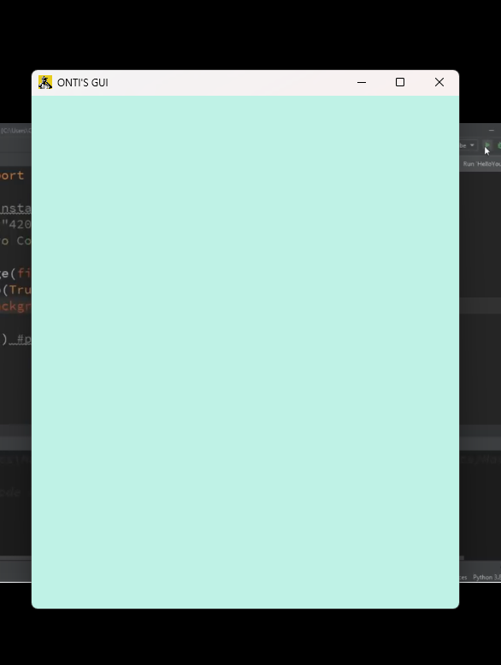

**Labels**

**Label –** an area widget that holds text and/or an image within a window

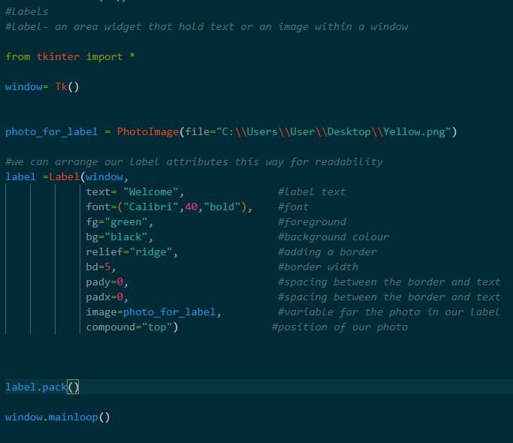

**We inserted “window ” as an argument for Label because of the Syntax:**

**Name of label= Label (master, attributes)**

**master-**what we are adding the label to. In this case, we are adding the label to the **window.**

**Buttons**

**Buttons-** perform action upon being clicked.

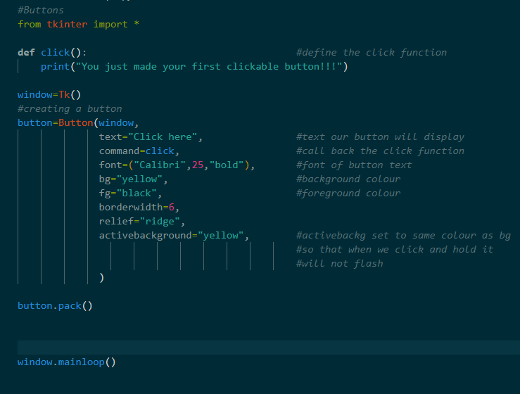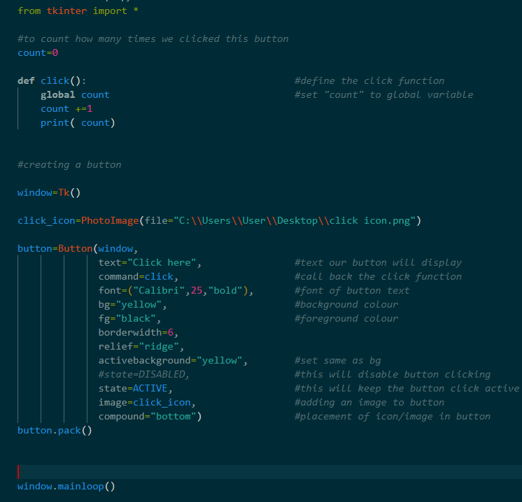

**Entry widget**

**Entry widget**- a textbox that accepts a single line of user input

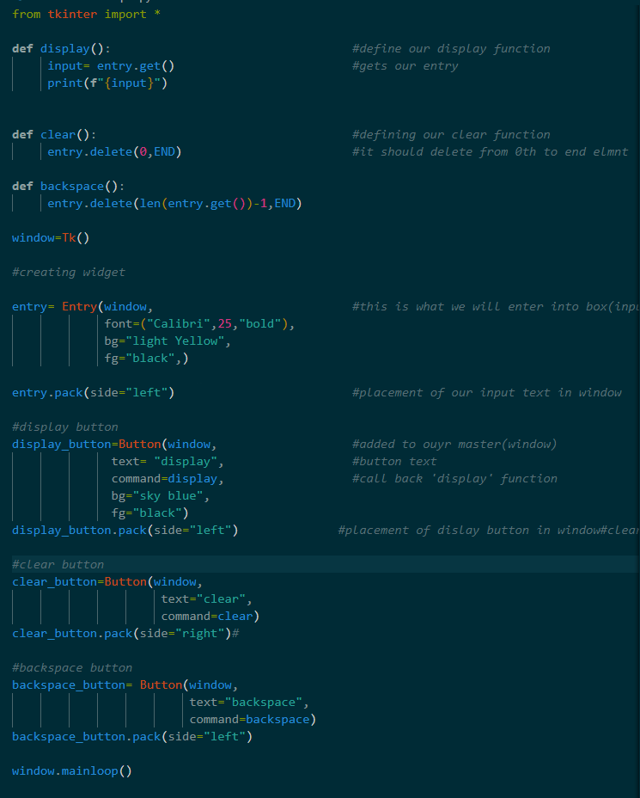

**entry.config (state=DISABLE) will disable entry after displaying it**

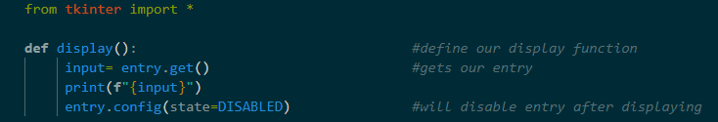

**show=”*” will hide characters and show asterisks instead. This is useful for passwords**

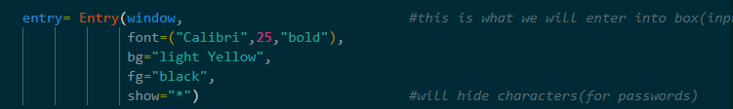

**Check Button**

**Check-button**

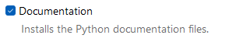

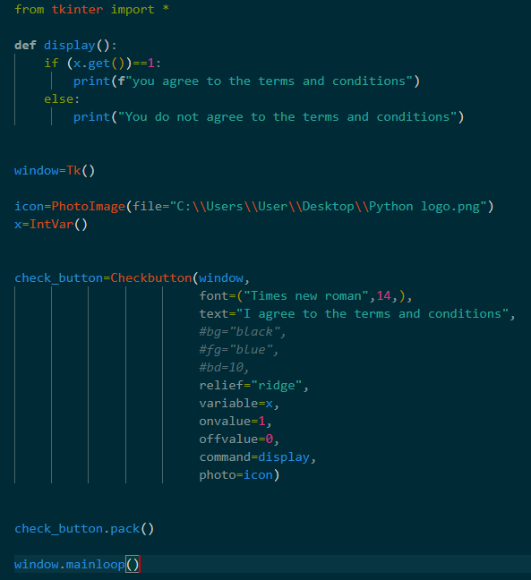

**Radio buttons**

**Radio buttons-** similar to check buttons/ checkbox but you can only select one from a group from tkinter import *

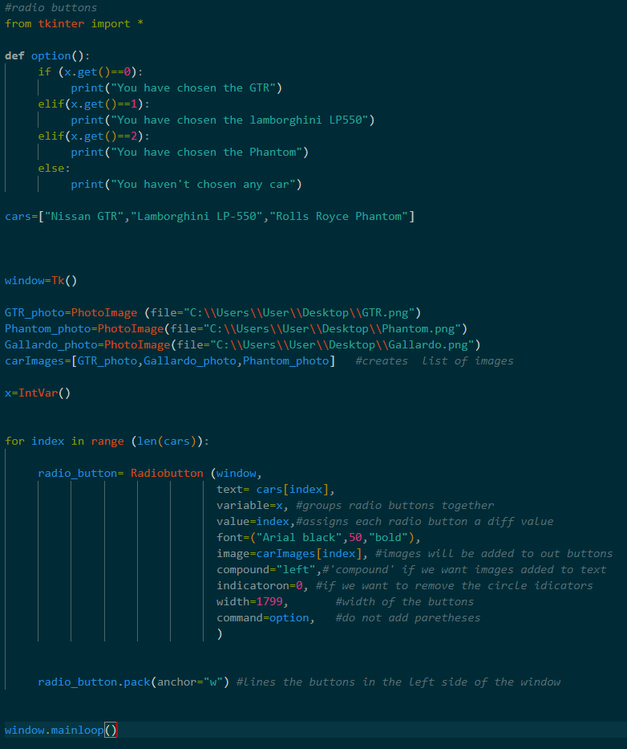

**Creating an interactive sliding scale**

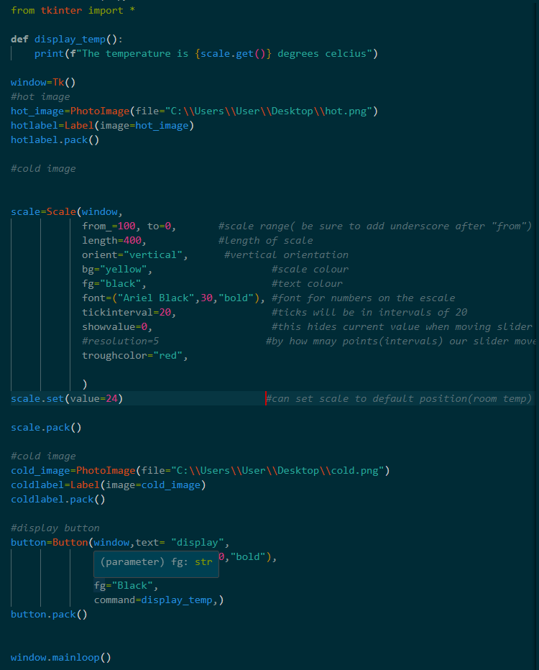

**OUTPUT**

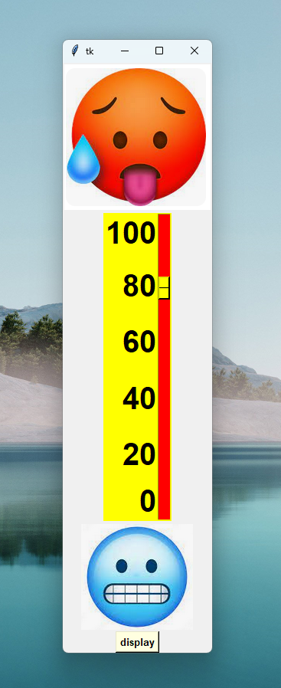

**CODE RUNS IN SEQUENCE!**

**How to install Tkinter/custom Tkinter (from beginning)**

**Vs code:**

**Create a virual environment**

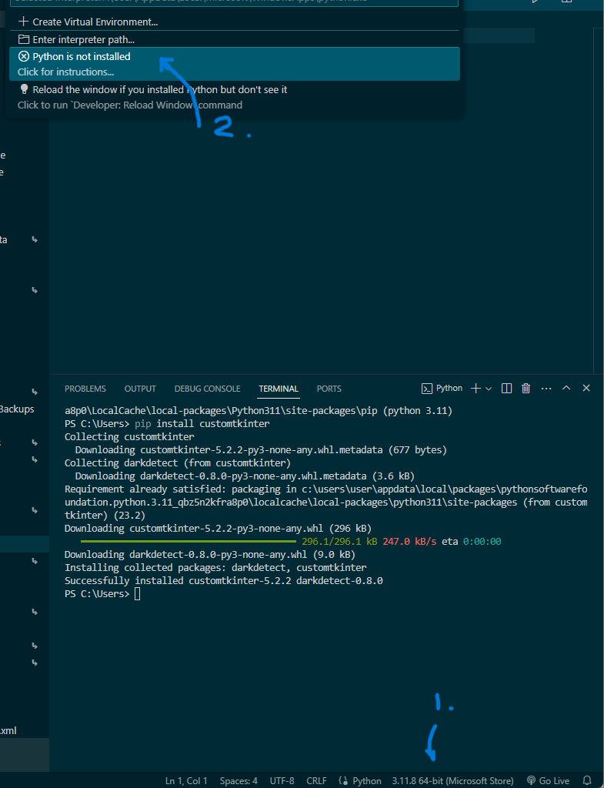

**Get path for your virtual environment in command prompt**

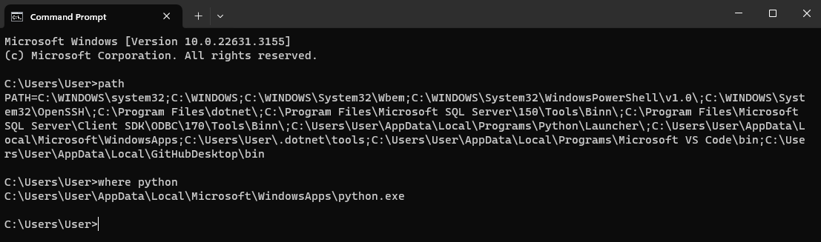

**How to check your python version**

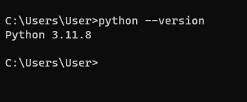

**How to install pip**

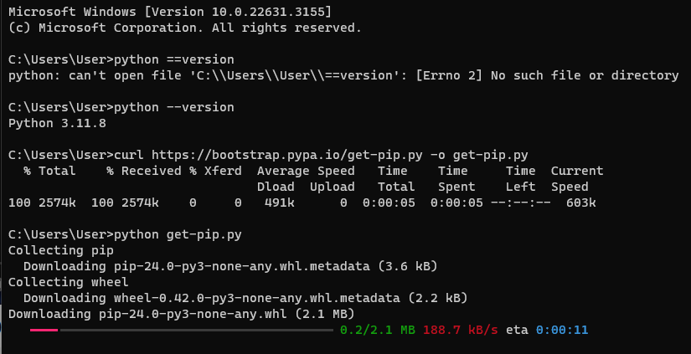

**Check pip version in command prompt**

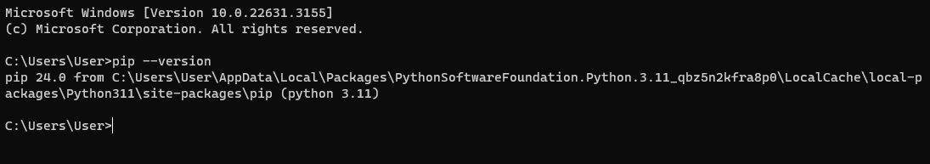

**Finally install your Tkinter**

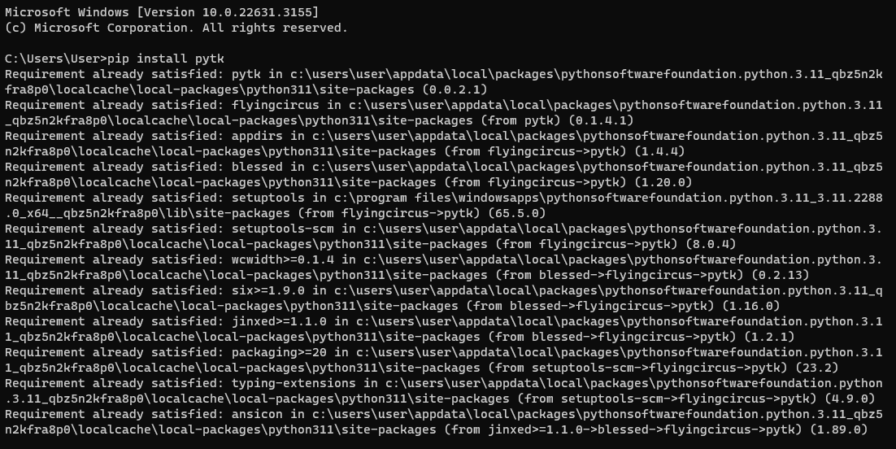

**List box**

**Listbox -** a listing of selectable text items within its own container

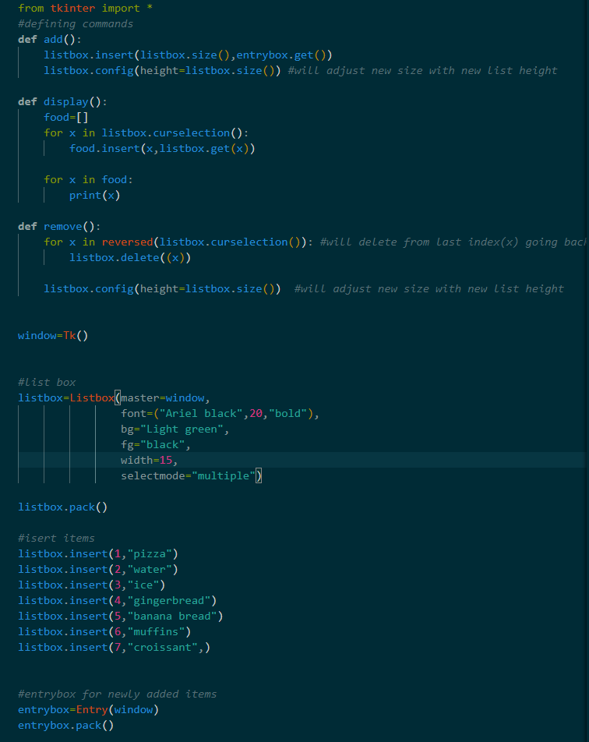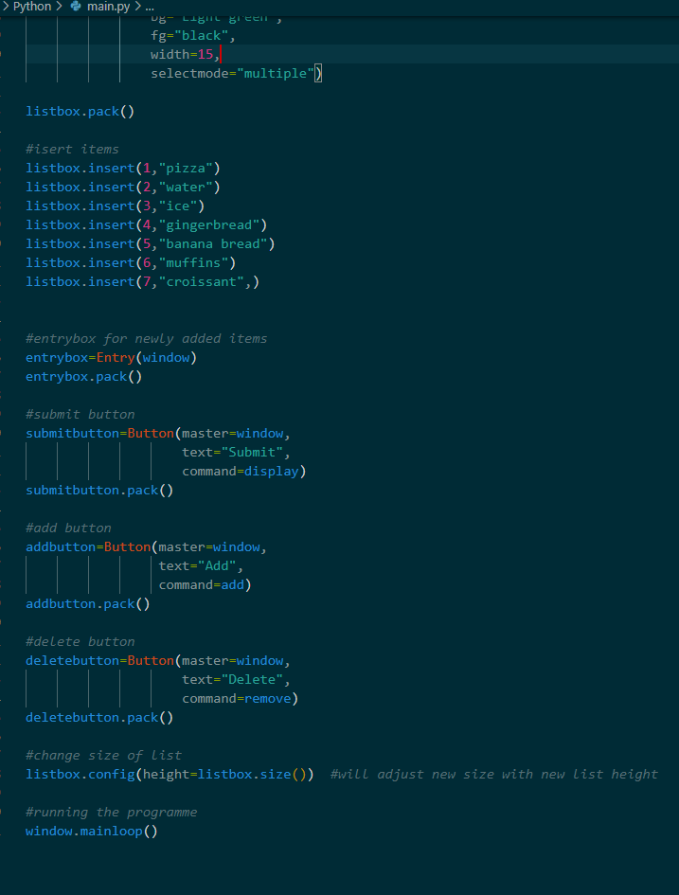

**Message box**

**Ordinary message**

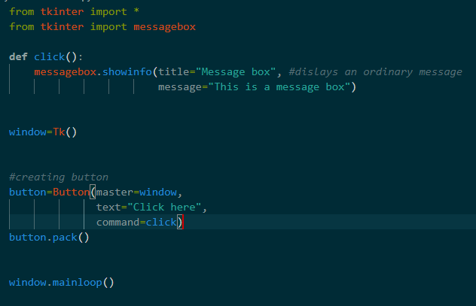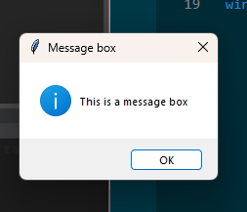

**Warning box**

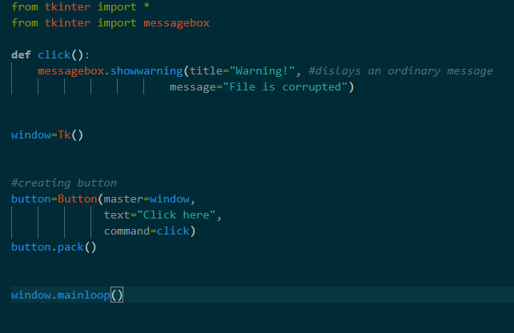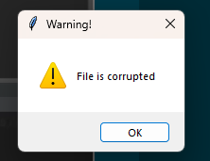

**Error box**

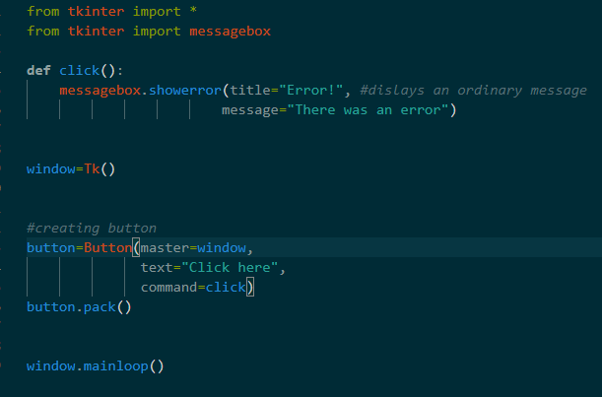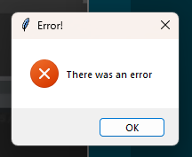

**Ask ok cancel**

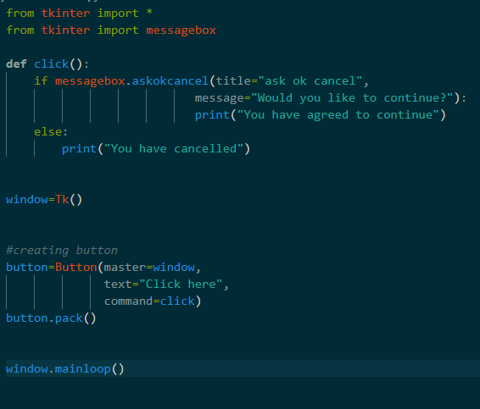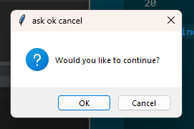

**Ask to retry box**

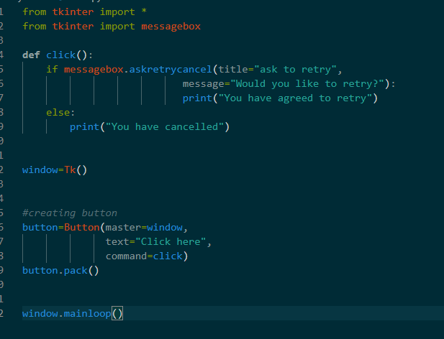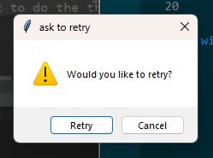

**Ask yes or no box**

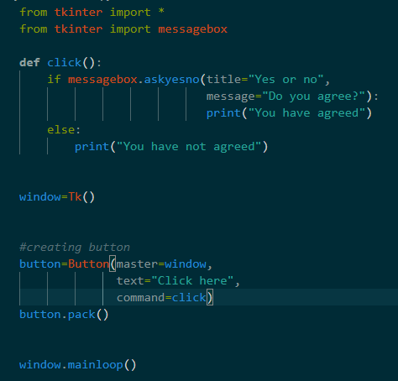

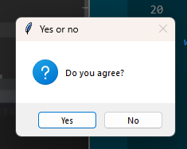

**Yes or no box.**

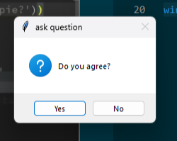**This one returns “yes” or “no” . Not our print statement**

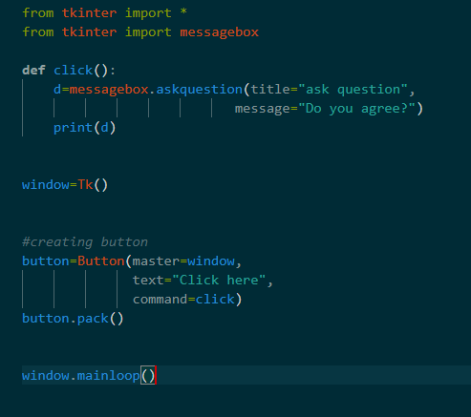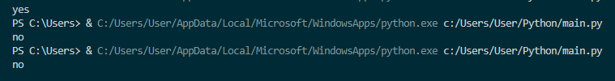

**Same as above but with if statement**

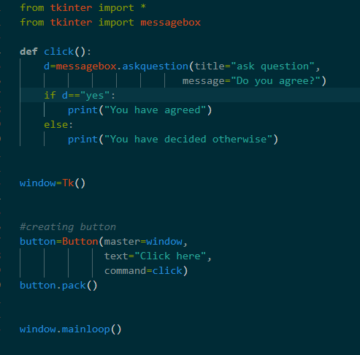

**Yes or no cancel box**

**Works with Boolean expressions**

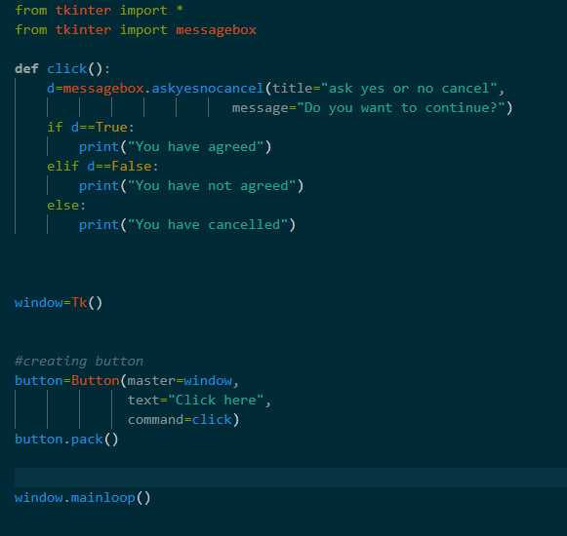

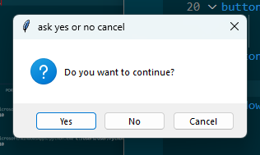

**Changing message box icon**

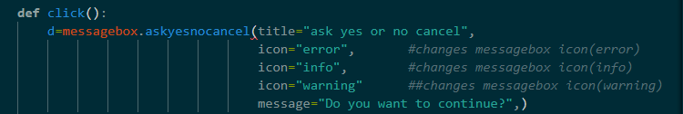

**Creating a colour chooser in Python**

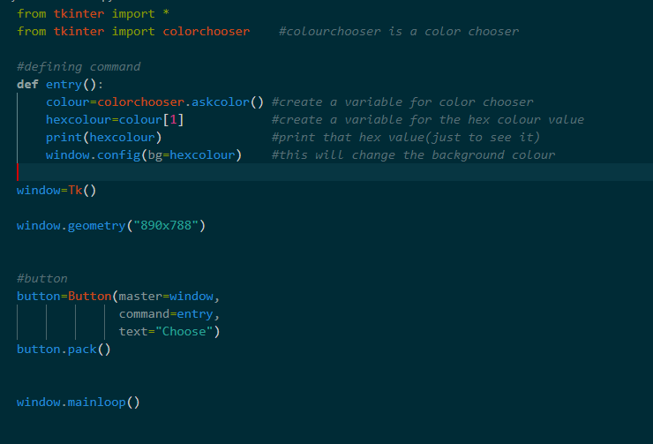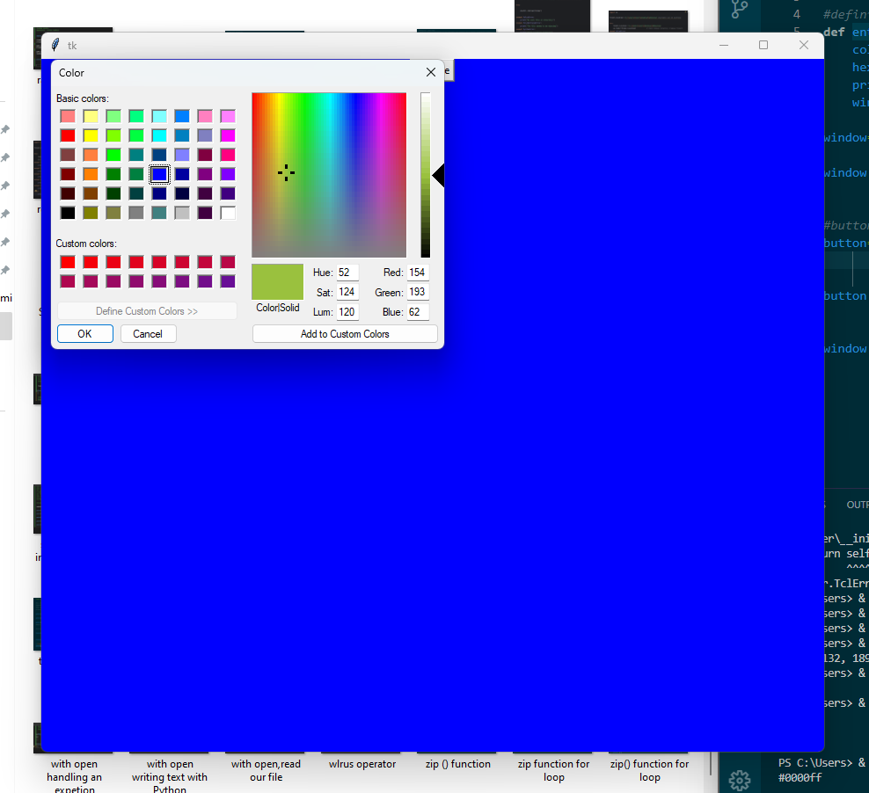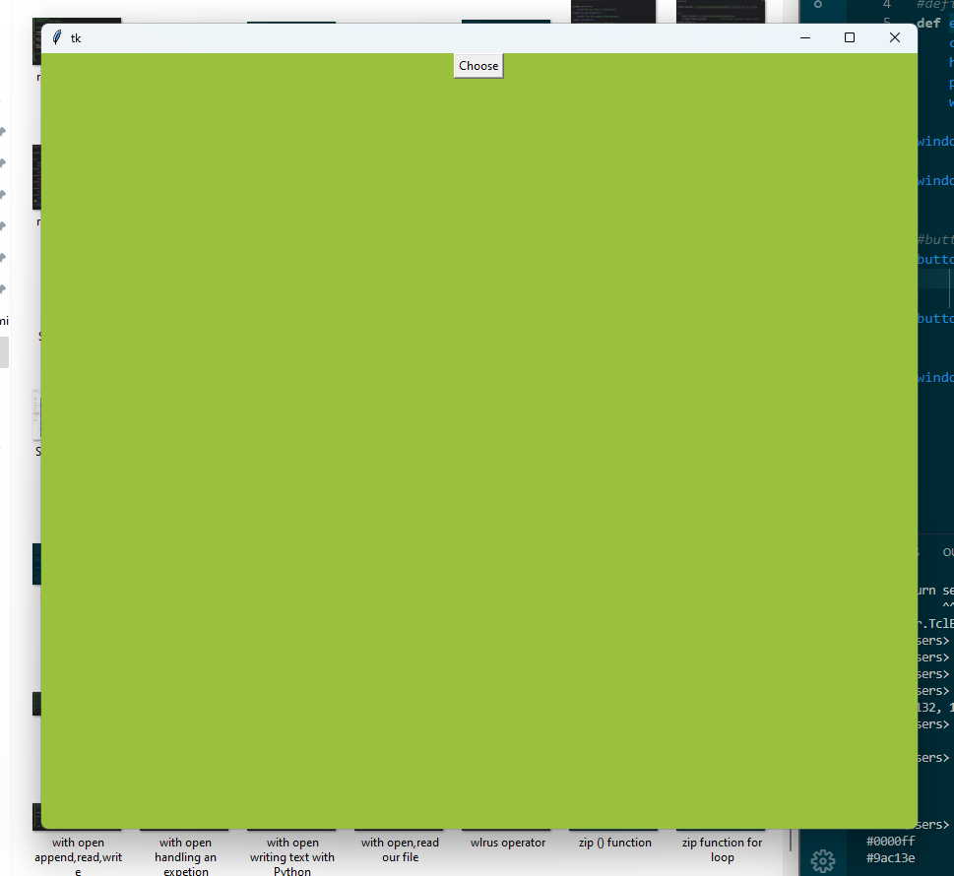

**Creating a Text area in Python**

**Text widget-**  functions like a text area, you can enter multiple lines of text

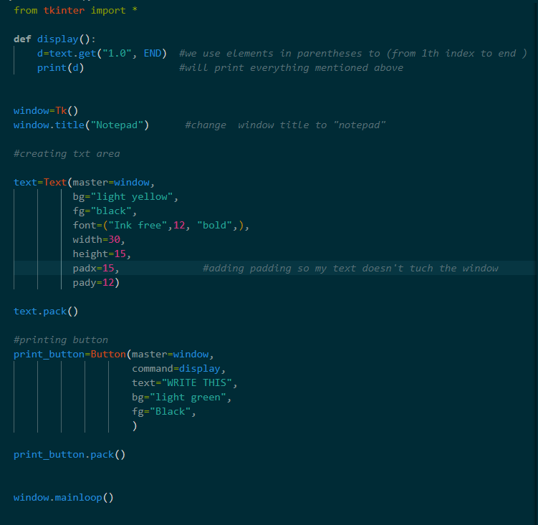

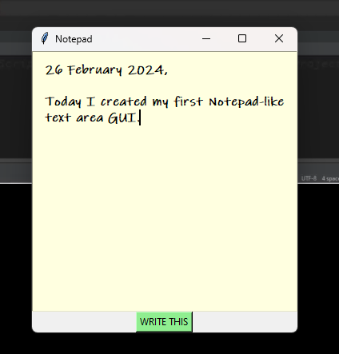

**File dialog(save)**

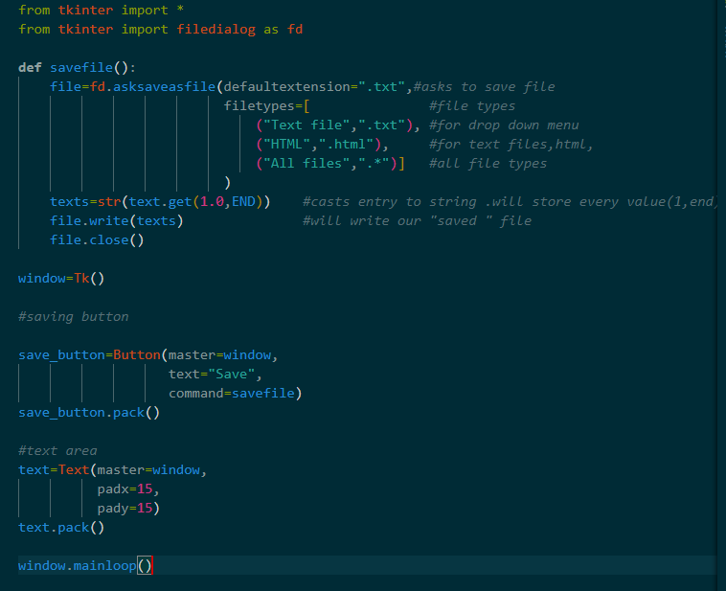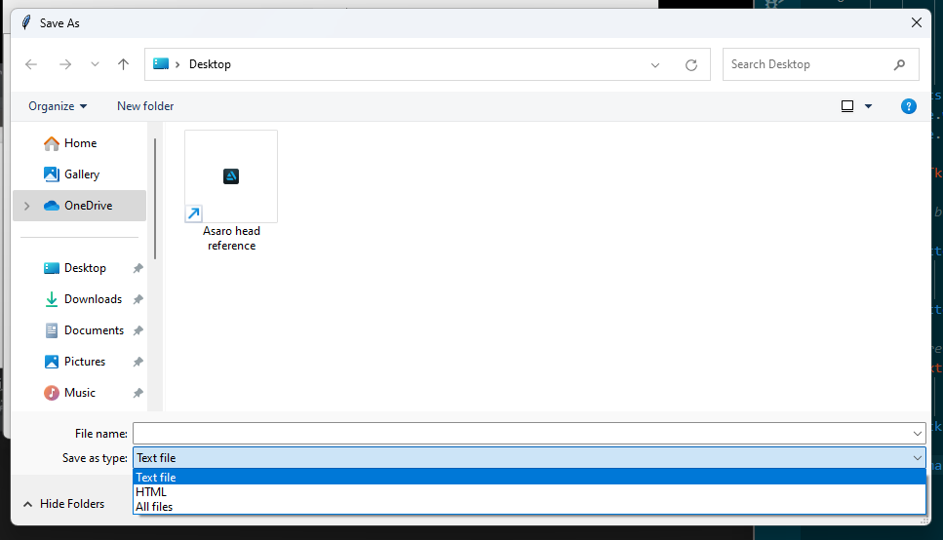

**Creating a menu bar in Python**

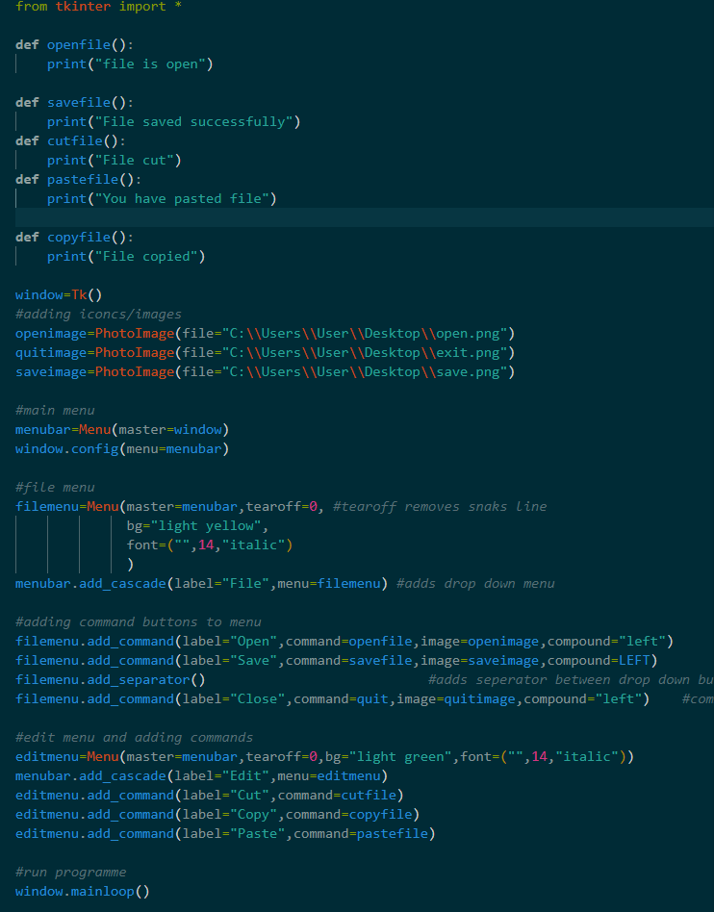

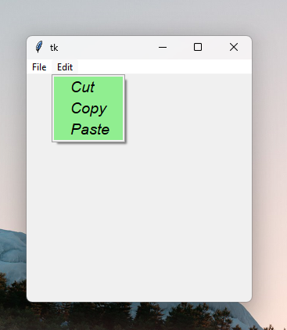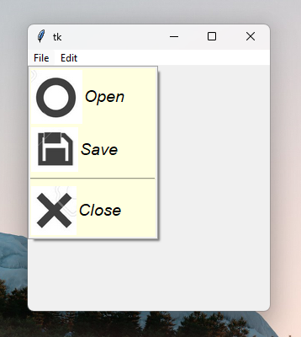

**Creating a frame in Python**

**Frame-** a rectangular widget container

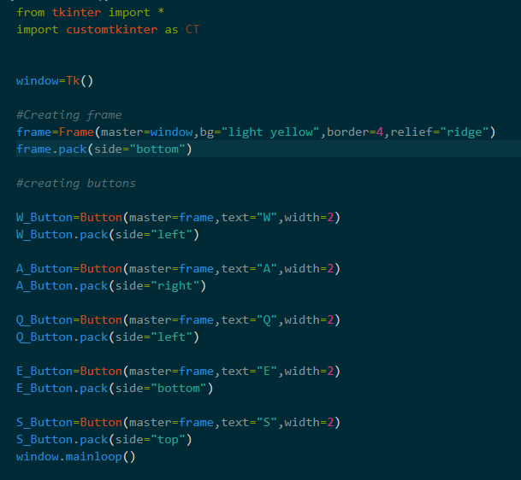

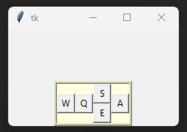

**Creating a new window in Python**

**Top level window-**new window “on top” of other windows linked to a bottom window. This type of window is directly linked to the main window . If we close the **main window**, the top level window also closes but if we do the opposite, the main window will not close. **Think of it like the game of Jenga**. **Top pieces==top level window, bottom piece==main window.**

**Tk()-** TK() is a **new independant window** and is not related to the original window.

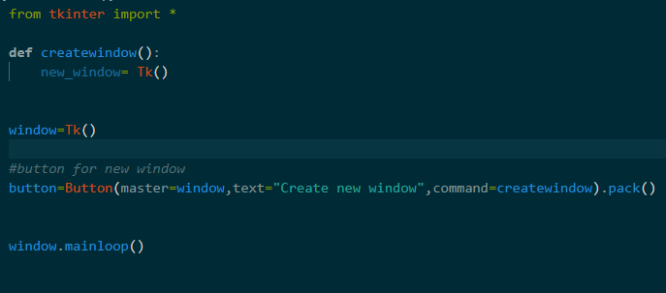

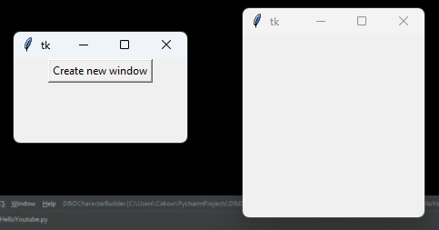

**Creating tabs for GUI**

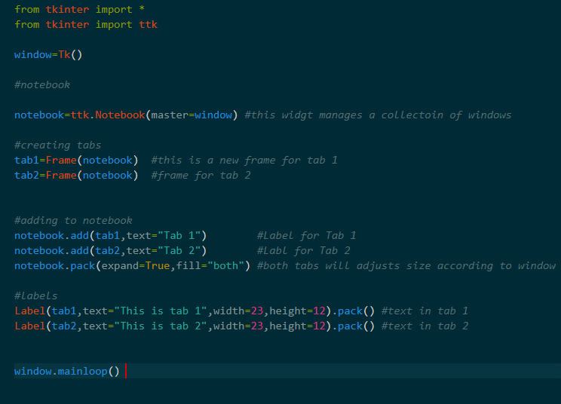

**Grid geomertry manager**

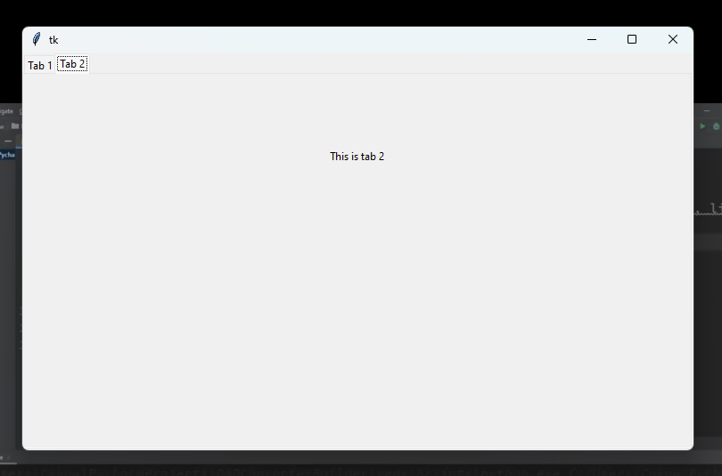

**Grid()-**  a geometry manager that organizes widgets in a table-like structure in a window.

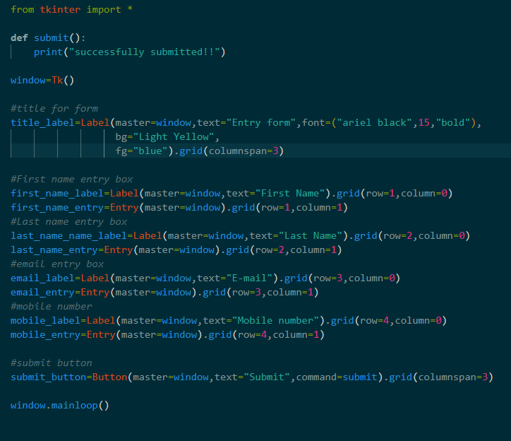

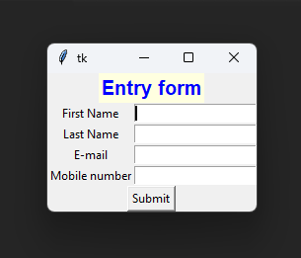

**Creating a progress bar**

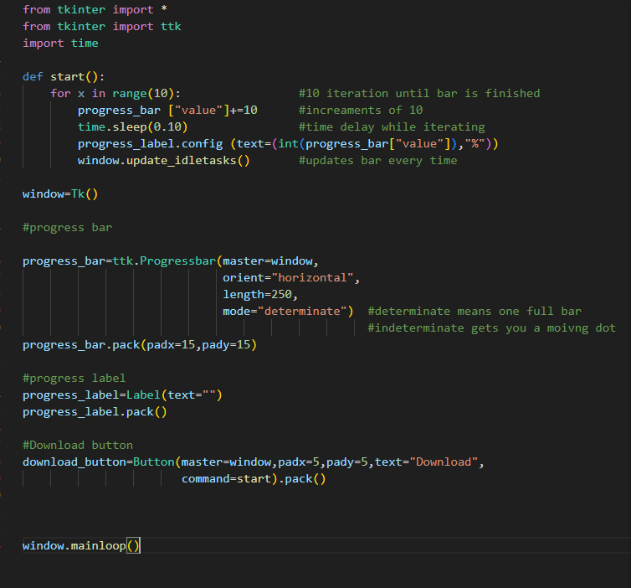

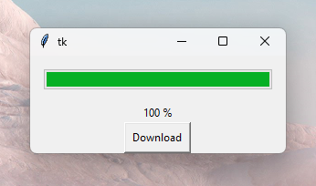

**Creating a canvas**

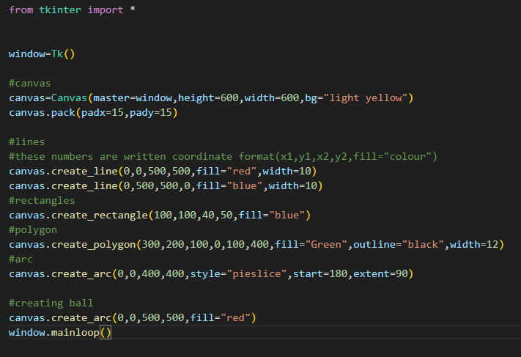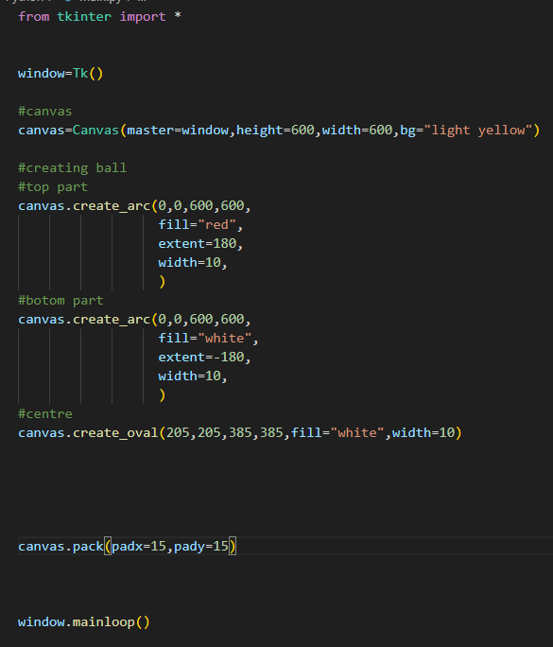

**Key events(Events and binds in tkinter)**

**Key events-**  this allows us to assign a certain action(function) to a key that is being pressed.The key is keyboard key.

**Syntax for this :**

**Window.bind(events,function)**

**Window.bind(“<>“,self defined function)**

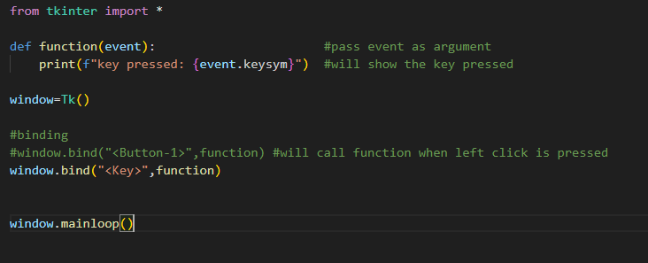

**The following code will enable us to view the individual keys we press**

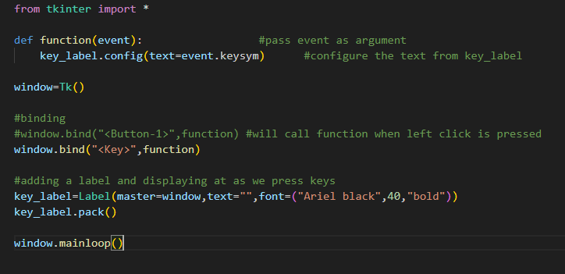

**Mouse events**

**Mouse events-**  this allows us to assign a certain action(function) to a button that is being pressed. The button is a mouse click.

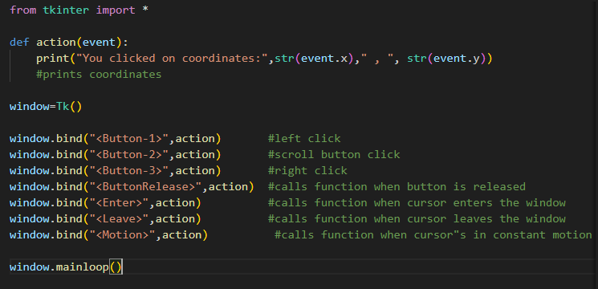

**Dragging and dropping widgets/images**

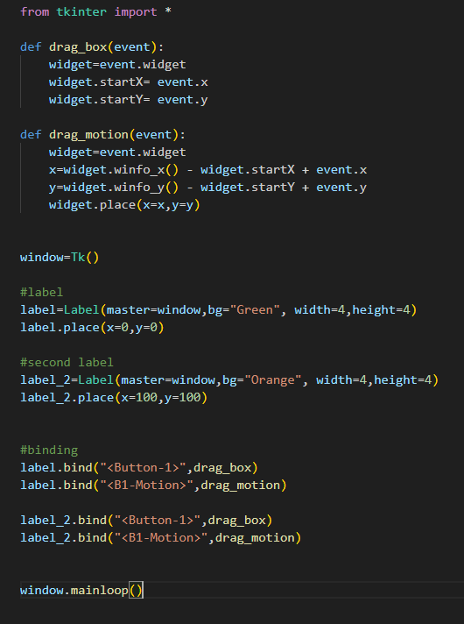

**B1-Motion engages the mouse button whereas just motion only works when the mouse is being moved.**

**Moving an image within a window(keybinding)**

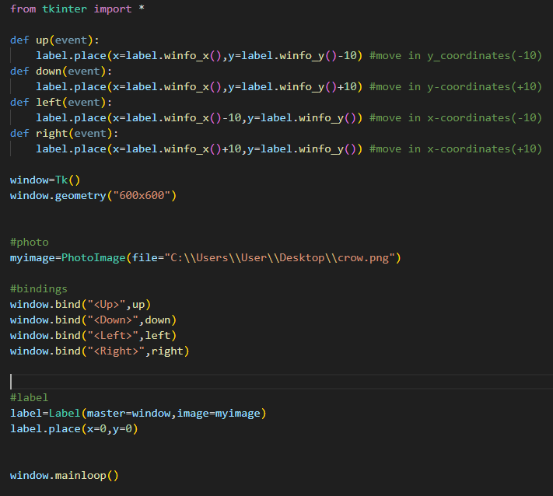

**Moving an image/label within a canvas**

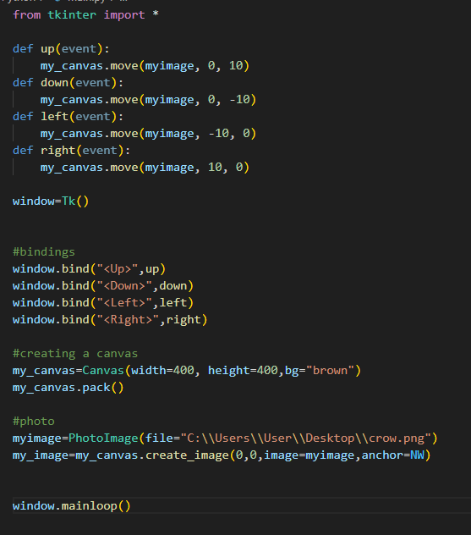**Basic 2D animation**

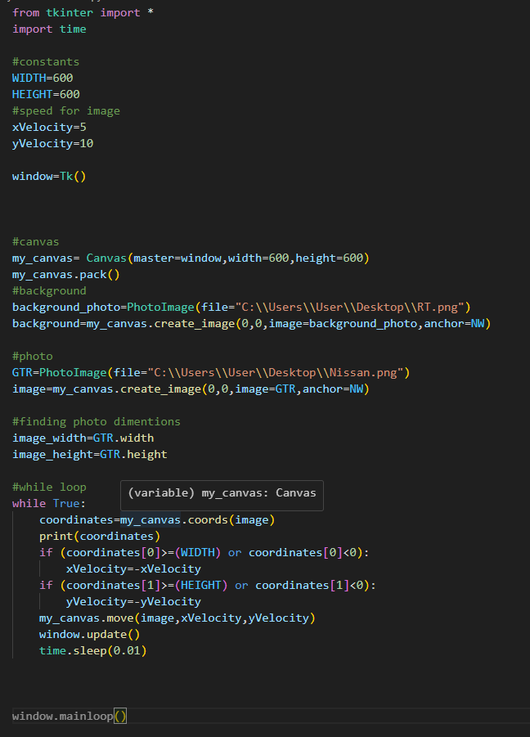

**Moving multiple objects within a canvas** 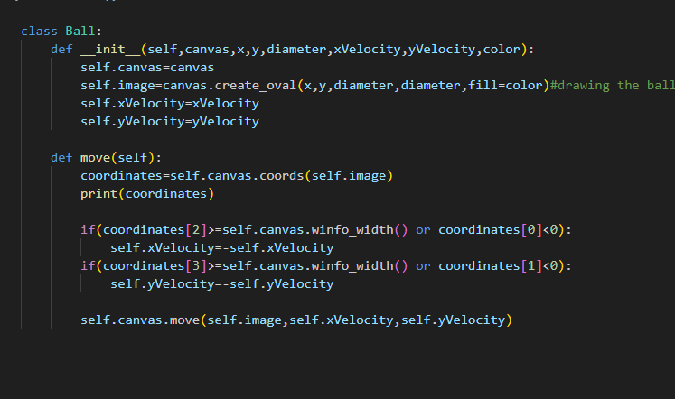

**We have to create a class which will serve as blueprint for our main module.**

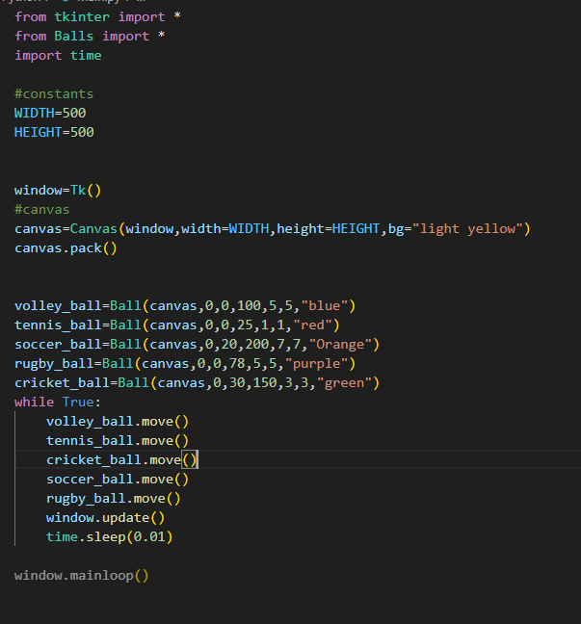

**Ball animation with another code**

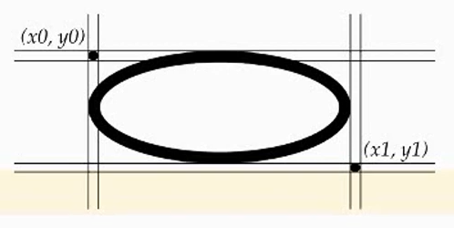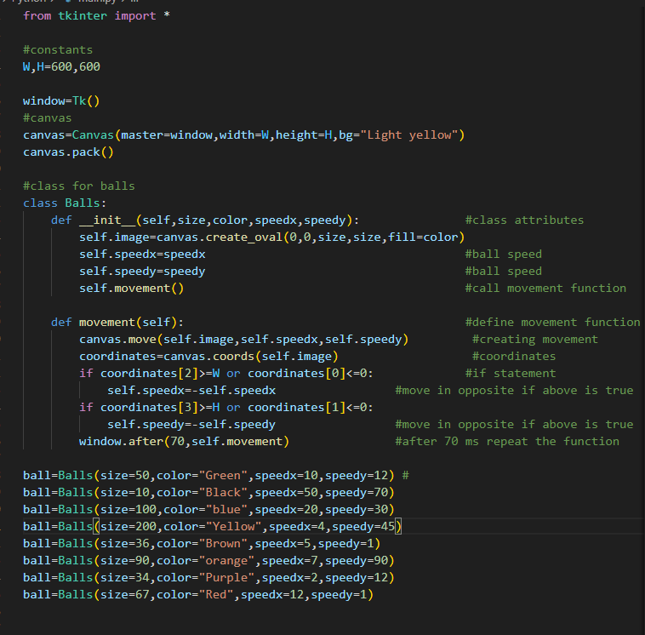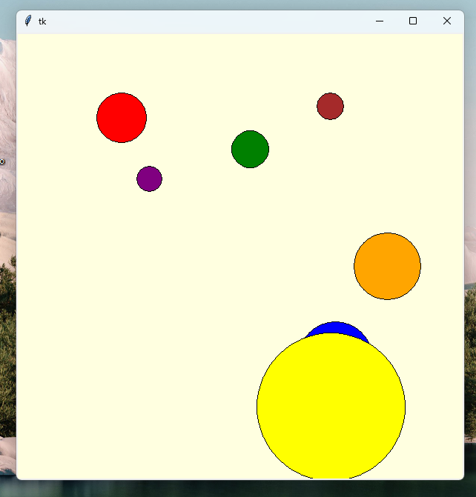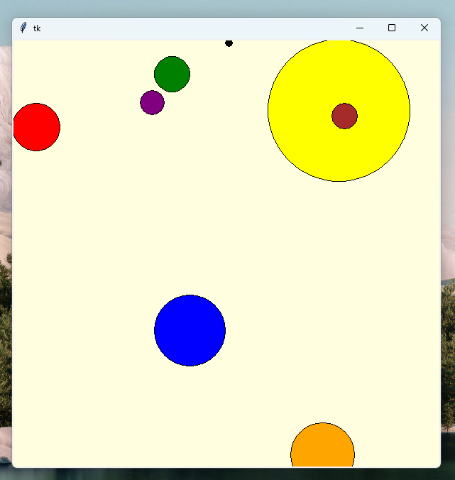

**Digital clock GUI**

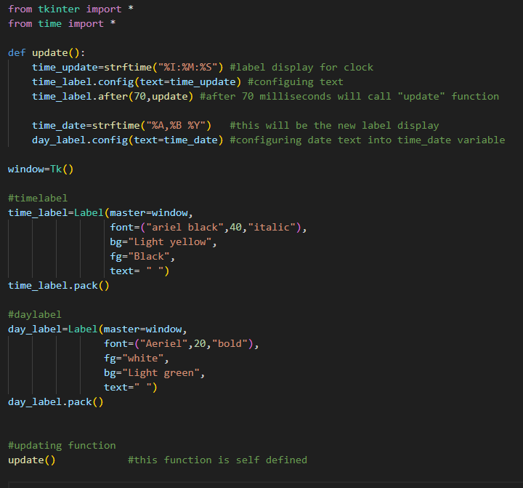

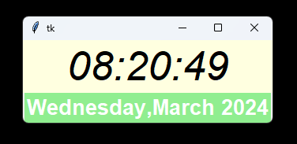

**Sending e-mails with Python**

A lot has changed since this tutorial was launched.

**What we will need to get set up:**

**Google Account-** Turn on two factor authentication.

**Google app password-** create 16-digit password. This will be used as password in Python for sending email via Python.

**End of link insert, ”app passwords”**

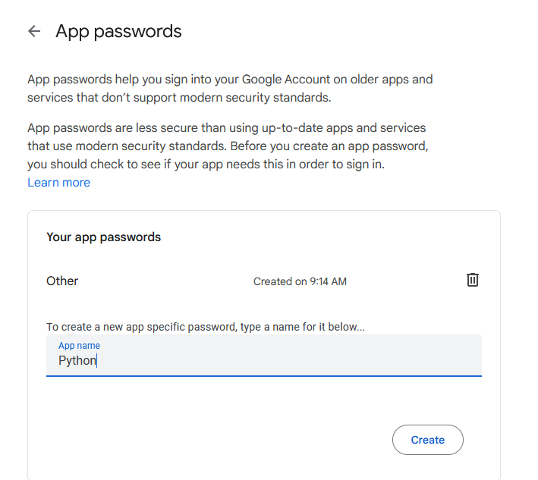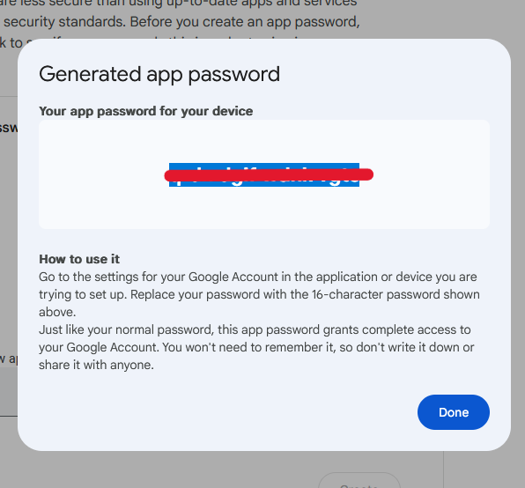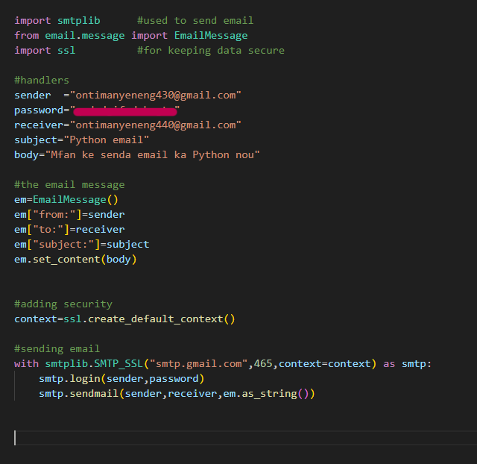

**Running Python files with command prompt**

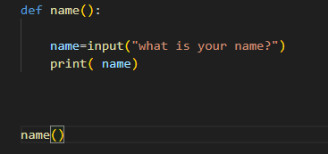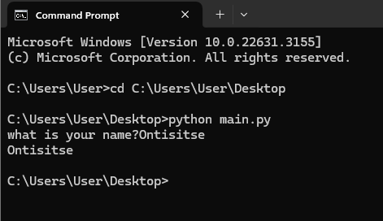

**PIP MODULE IN DEPTH**

**Using pip to install packages and modules in python**

**Outdated packages**

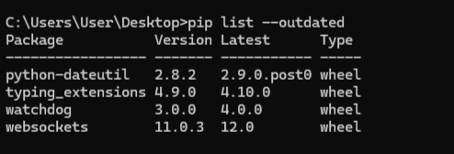

**List of commands**

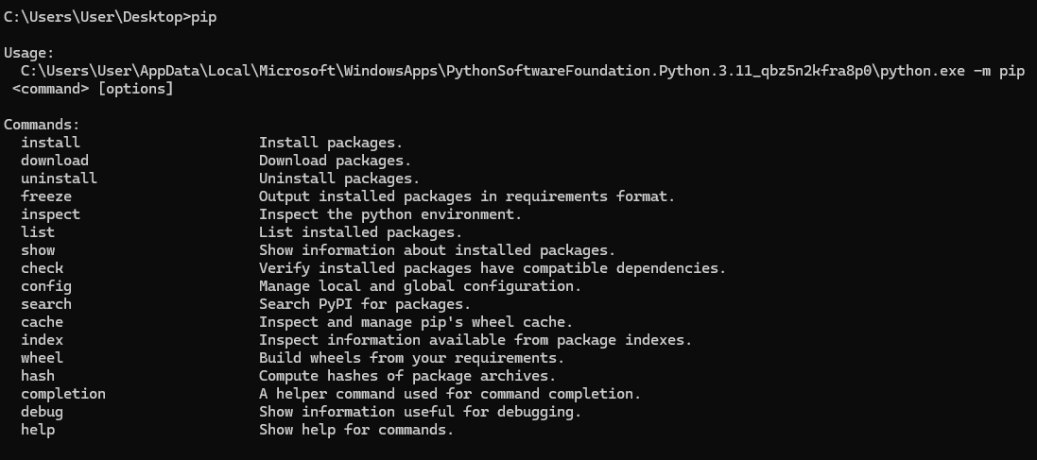

**List of installed packages and modules**

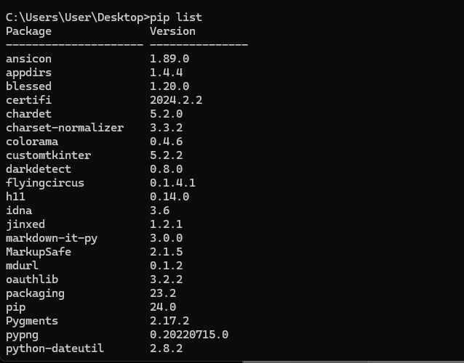

**Installing packages/ modules**

**installing update to existing module**

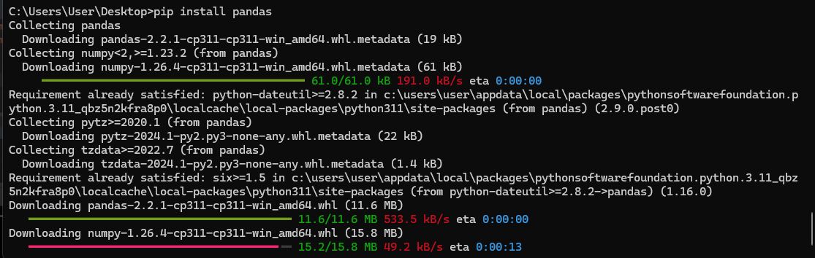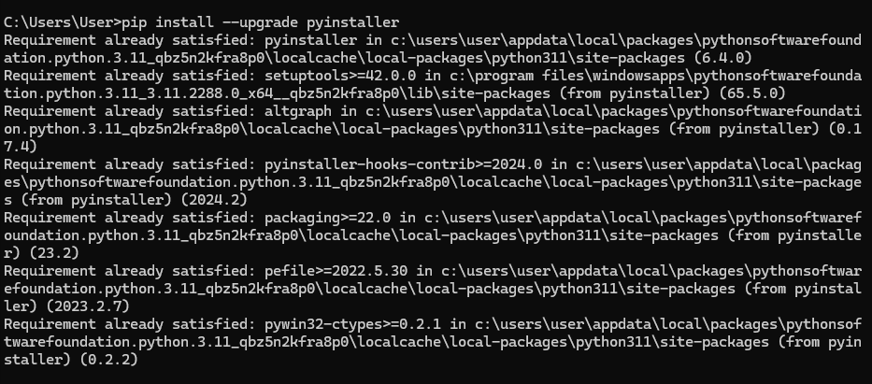

**Converting Python file(.py) into Application (executable)**

**First create a folder on Desktop where you will store you python file, icon for the programme if you want. The Icon file will have to be converted to an icon using “convert to ico” on Google. Once that is done. Go to command prompt**

**Change directory to where you file is**

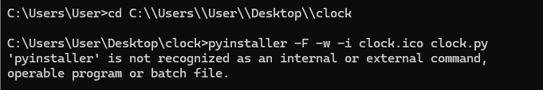

**Some programmed might not be able to run this pyinstaller module. There is a way around that.**

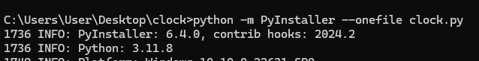

**The programme will run after this**

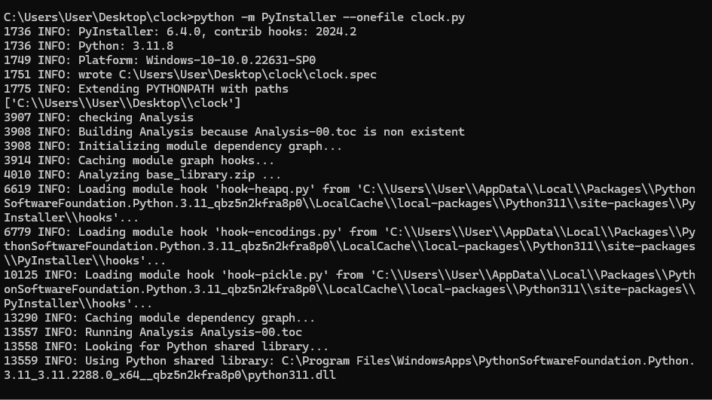

**Creating a basic GUI calculator in Python**

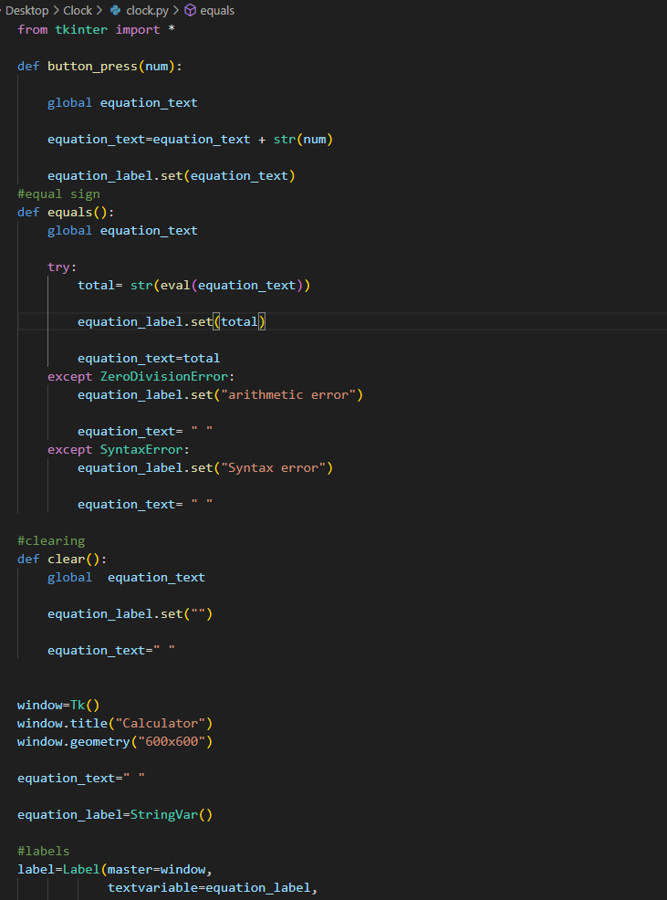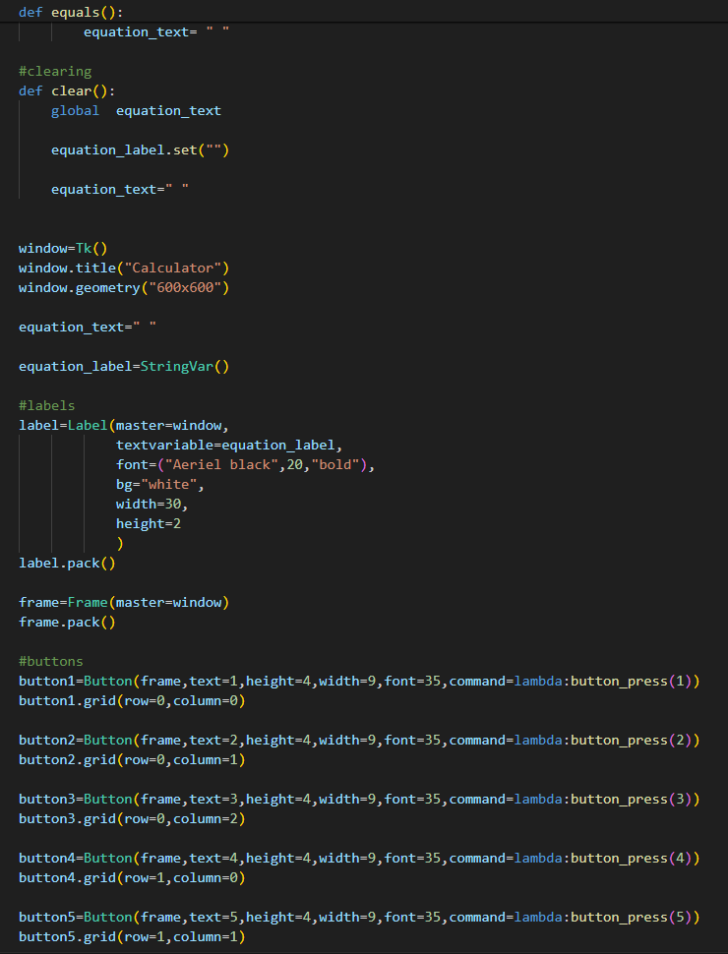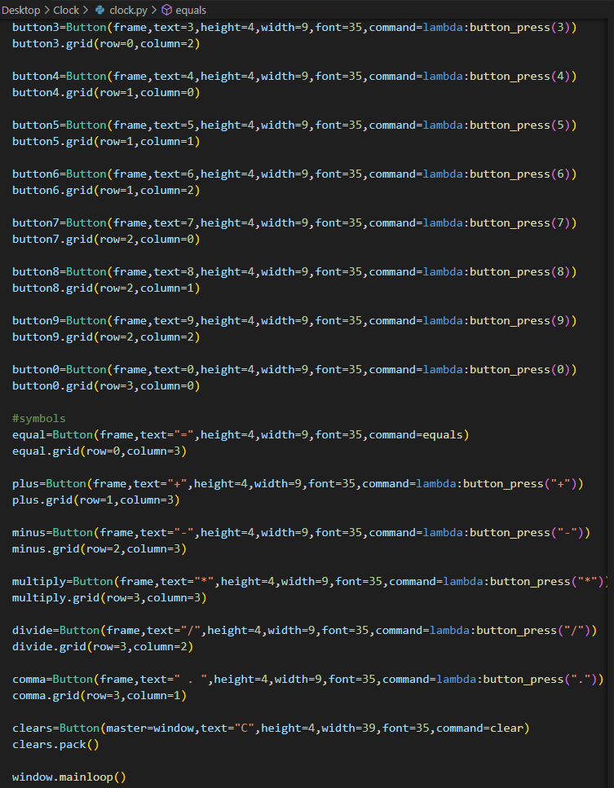

**Creating a text editor**